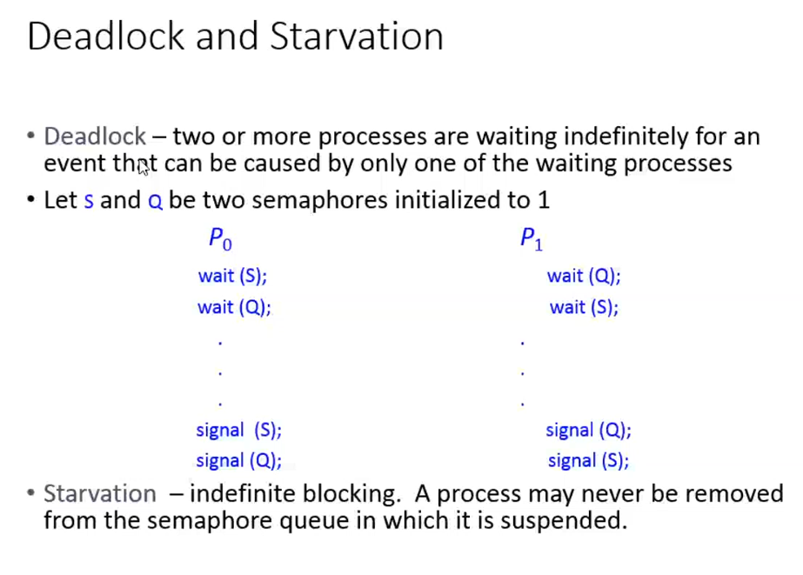

When P0 (or) P1 executing separately wait(S) and wait(Q) is done successfully and P0 enters into the critical section.

**When P1 can never enter??**  
After P0’s wait(S) and wait(Q) S and Q 🡪 0. So P1 cannot enter into the critical section.

**When P0 can never enter??**  
After P1’s wait(S) and wait(Q) S and Q 🡪 0. So P0 cannot enter into the critical section.

**When both P0 and P1 cannot able to enter into the critical section????**  
P0 executing wait(S) S 🡪 0  
P1 executing wait(Q) Q 🡪 0  
Now both the semaphore variables are 0, From now when P0 and P1 executing any wait() fully goes and stuck upto into the infinite while loop. So after this condition, both the process P0 and P1 will not proceed further. (Dead lock condition is achieved)

**Readers and writers problem**

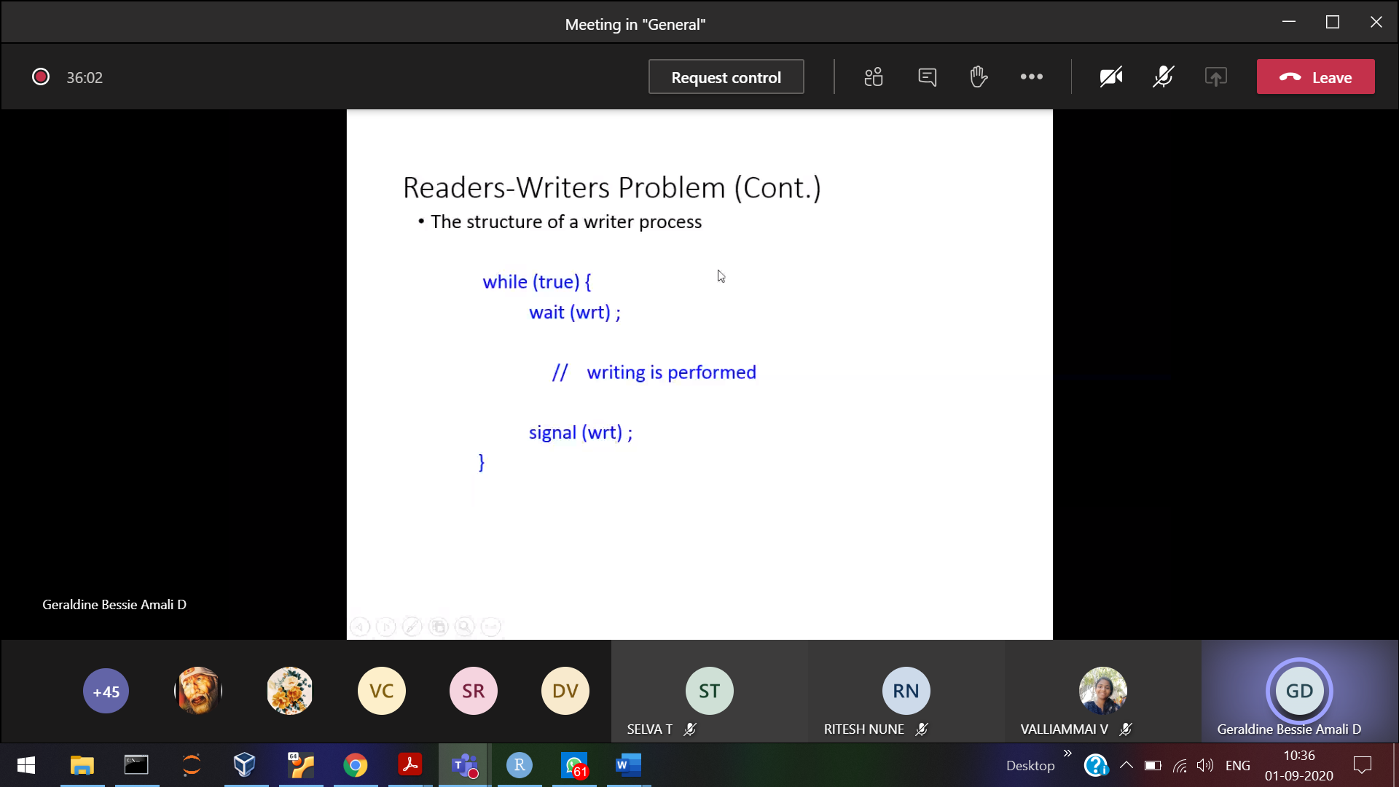

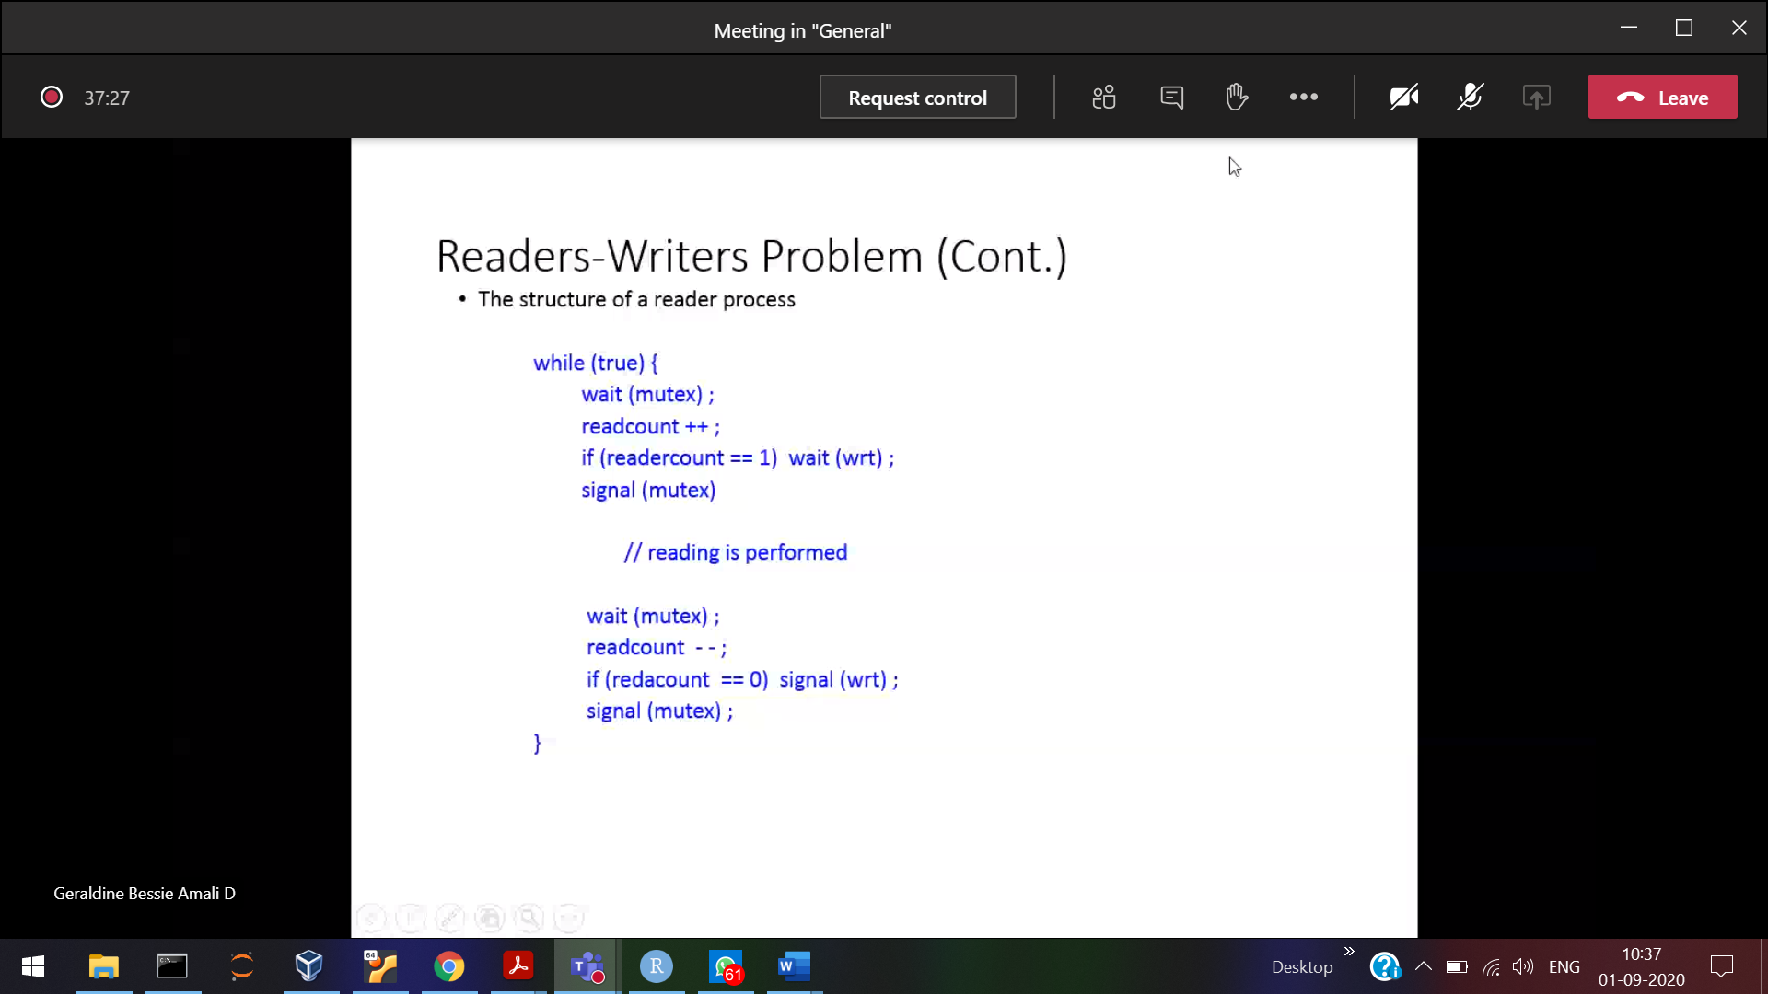

Practice for reader and writer simultaneously

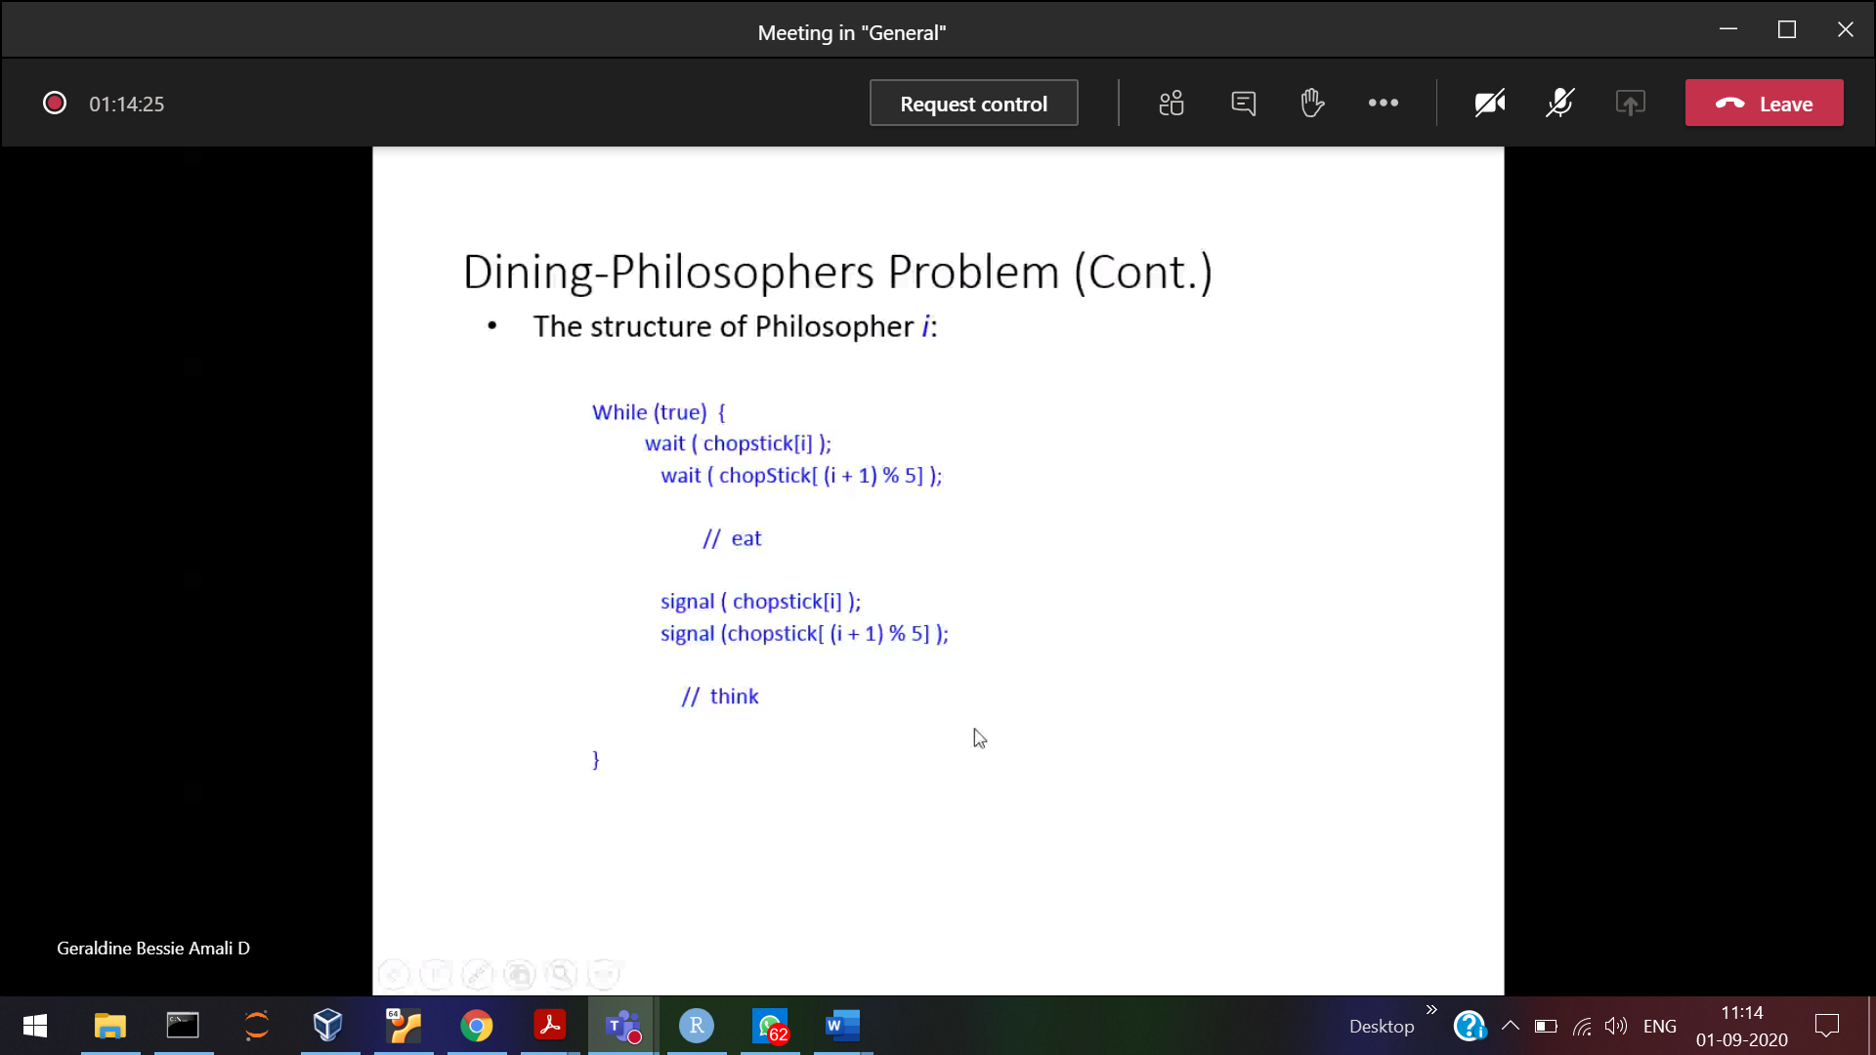

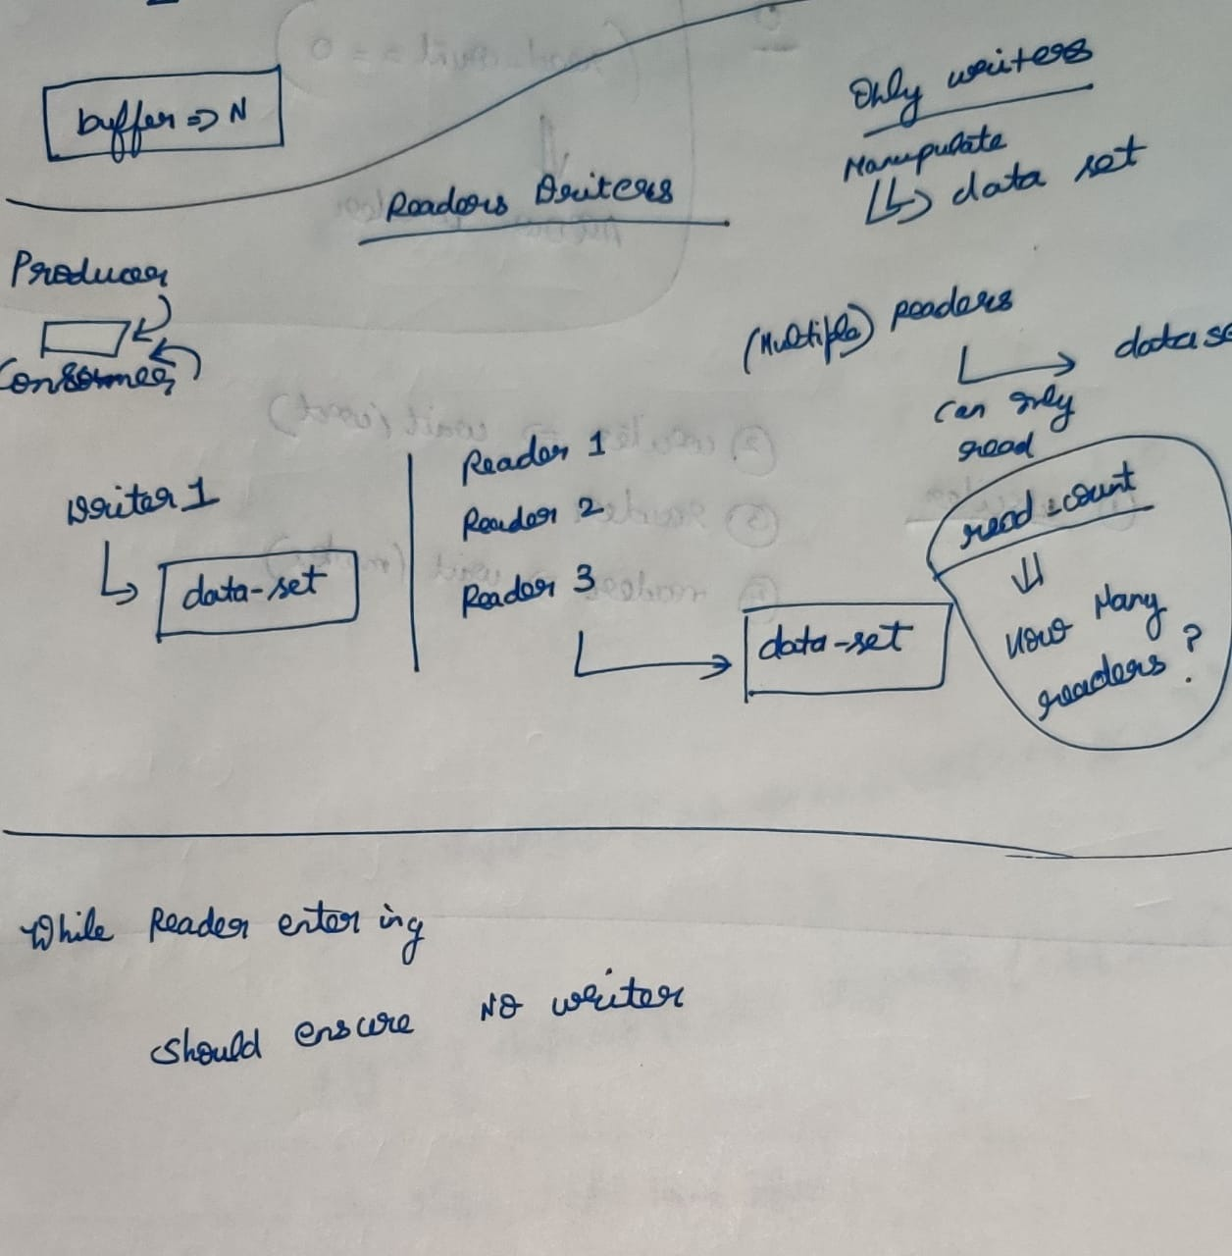

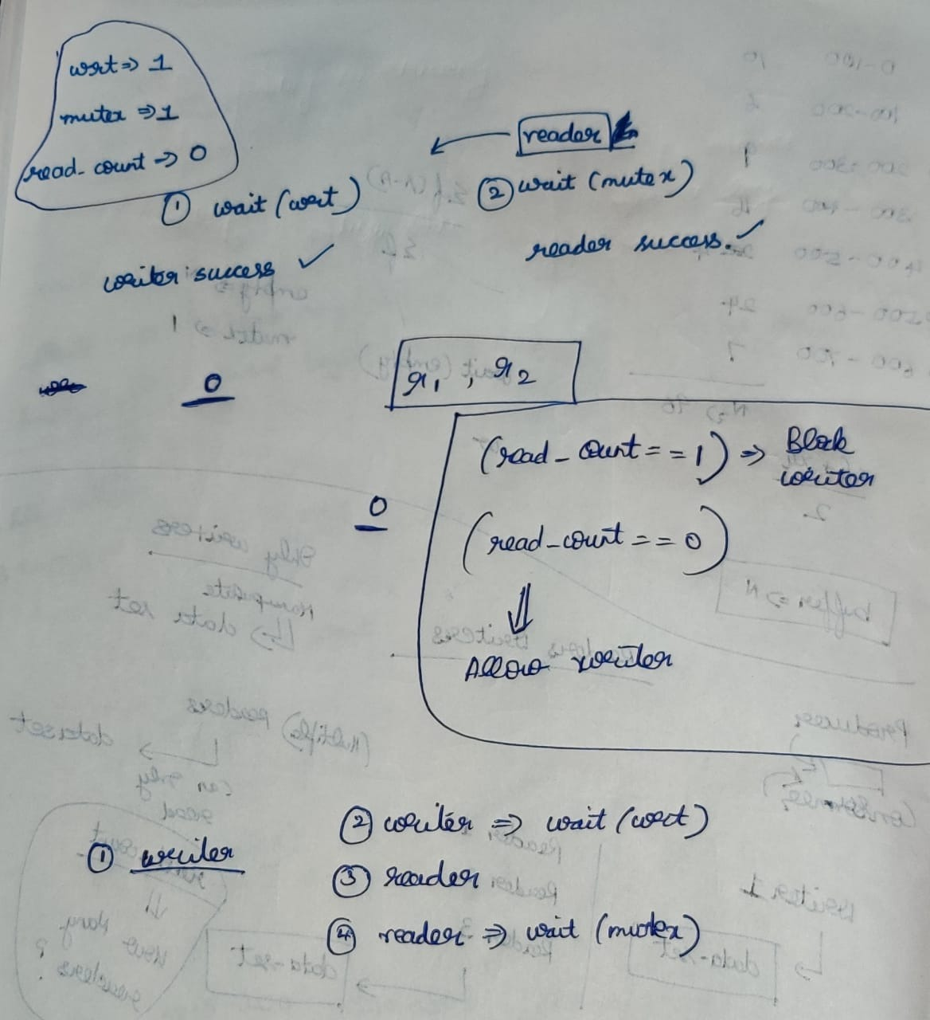

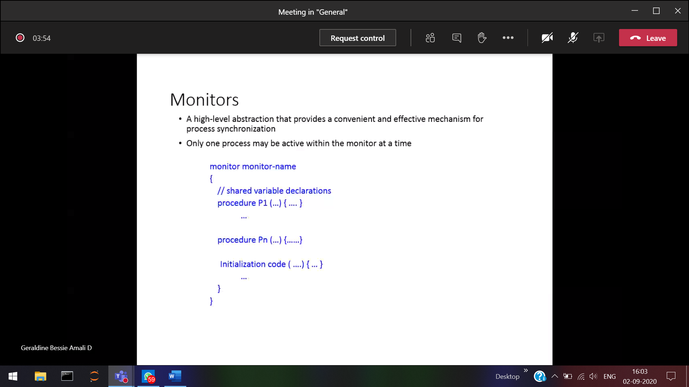

Abstract data-type 🡪 Similar to classes and structures

Shared variable 🡪 like buffer in producer and consumer problem + procedures which operate on the shared variable. Also ensures only one process at a particular time can access the monitor. [ All are encapsulated]

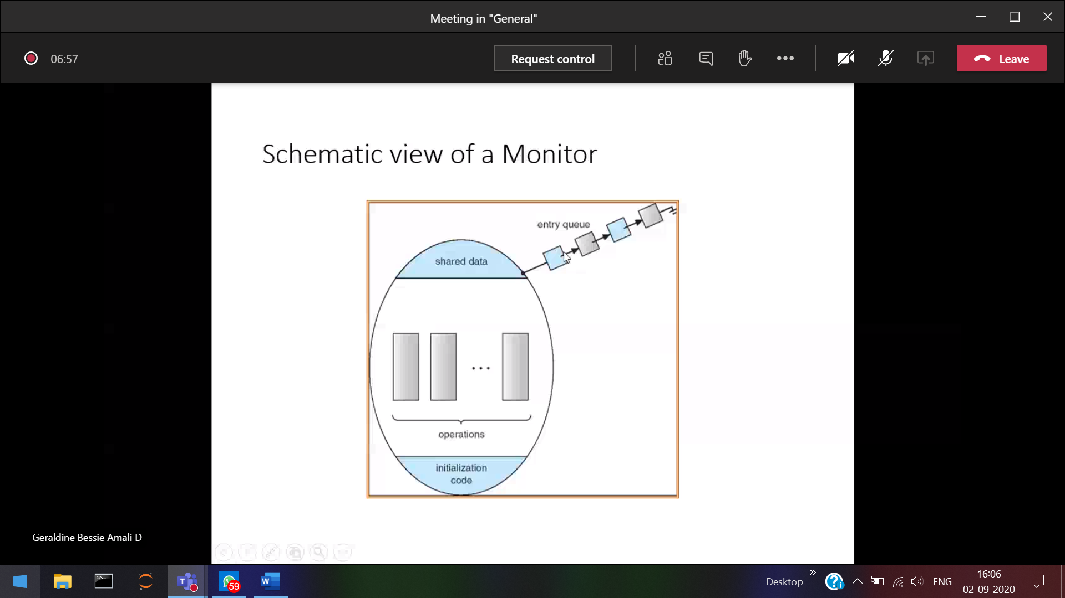

No more than 1 process can come in the Monitor (Implicitly Monitor will take care of it) and provide mutual exclusion

P1 comes in and hold the lock, So all the process should wait in the queue, Once after P2 releases the clock. Then only P2 can enter.

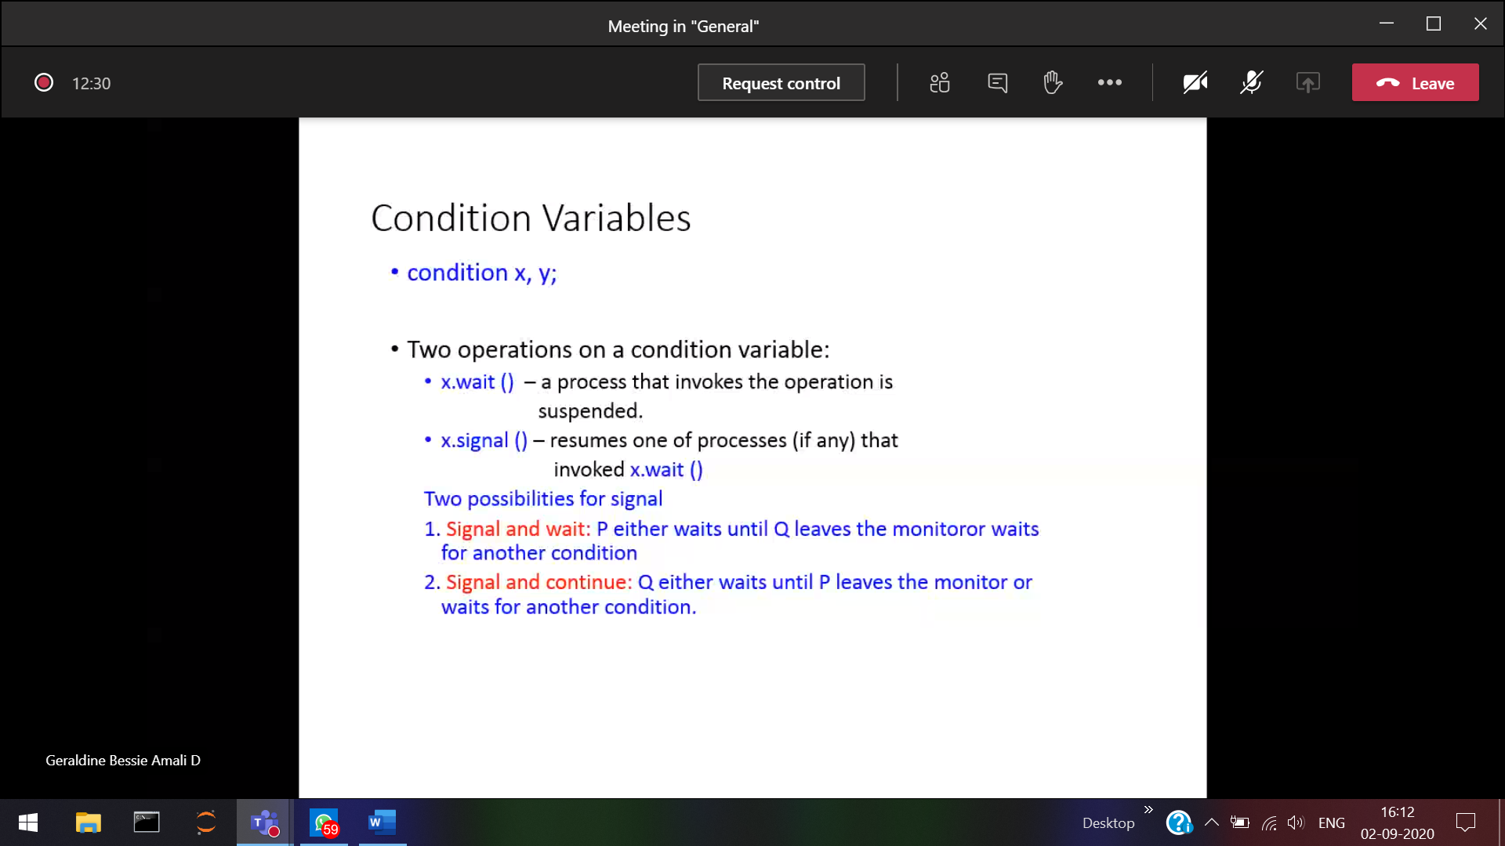

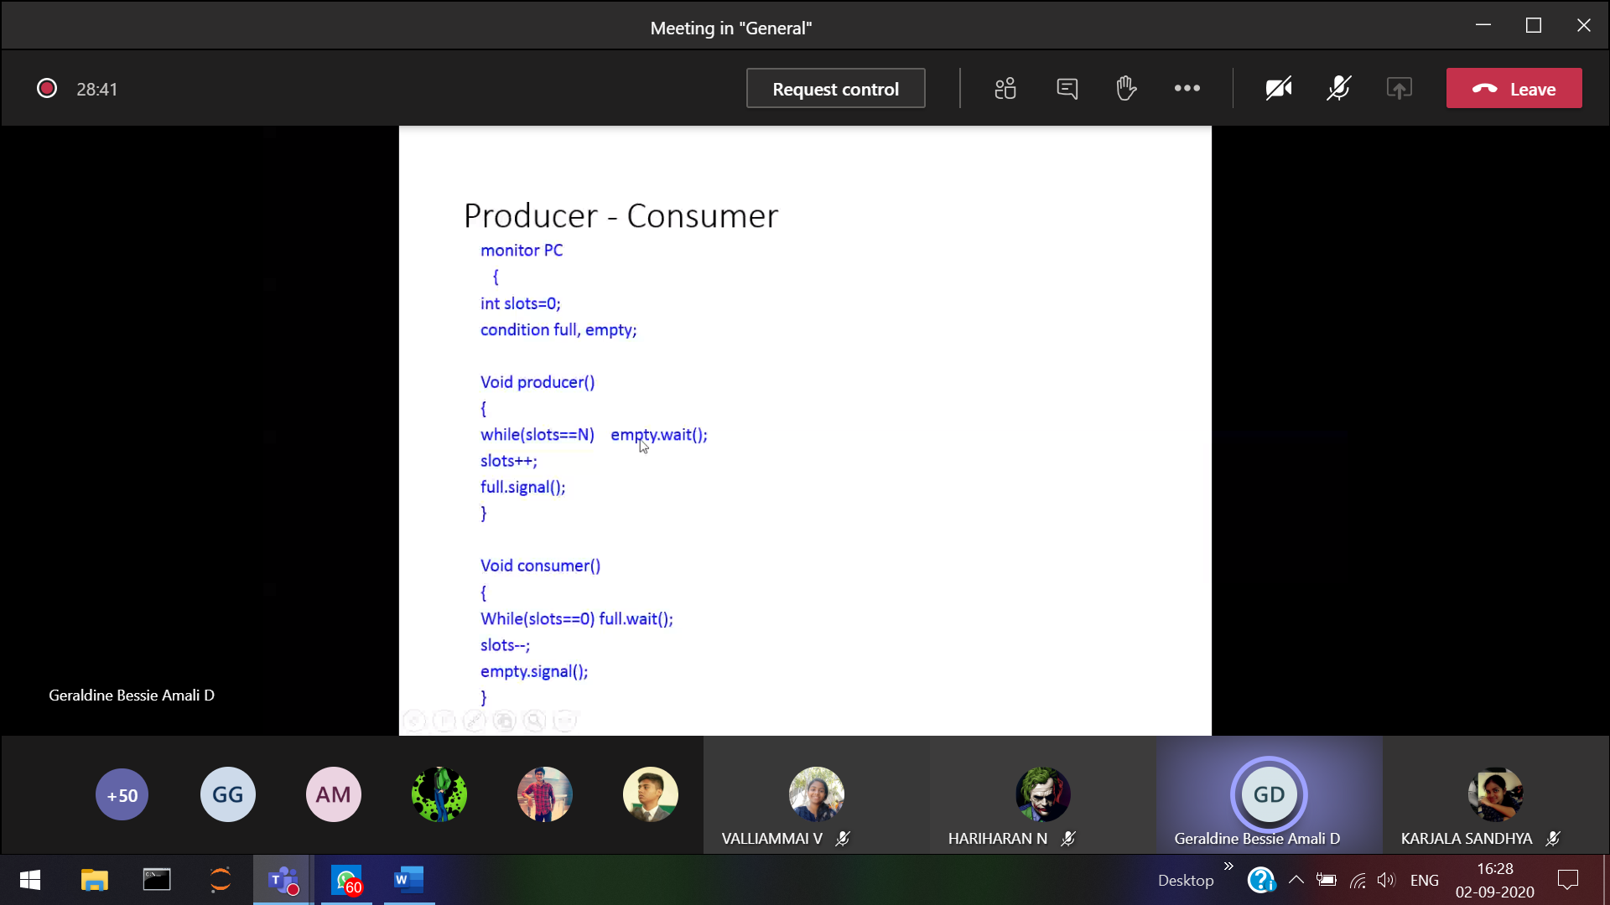

If no consumer waiting, producer will produce and go out

WHEN PHILopher wants to eat

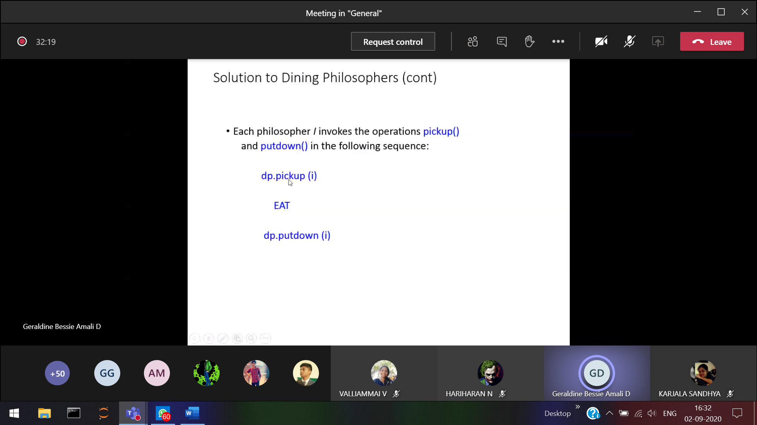

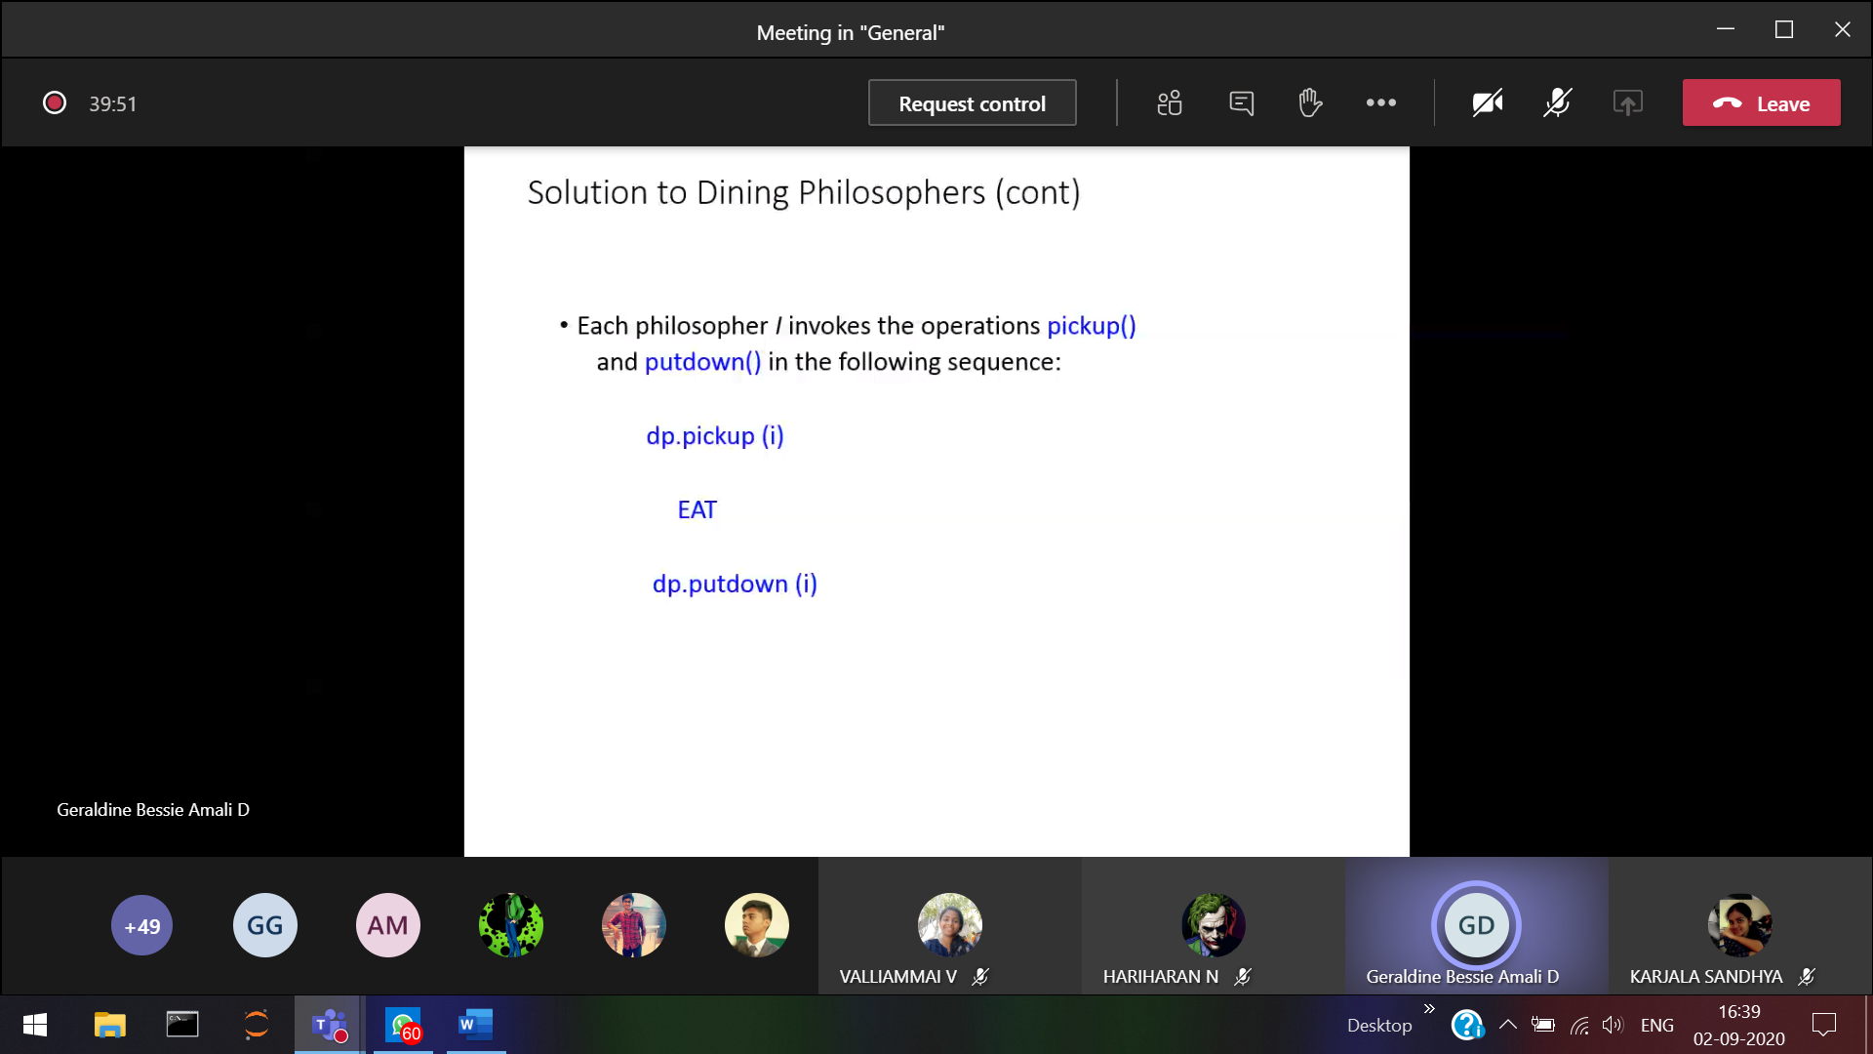

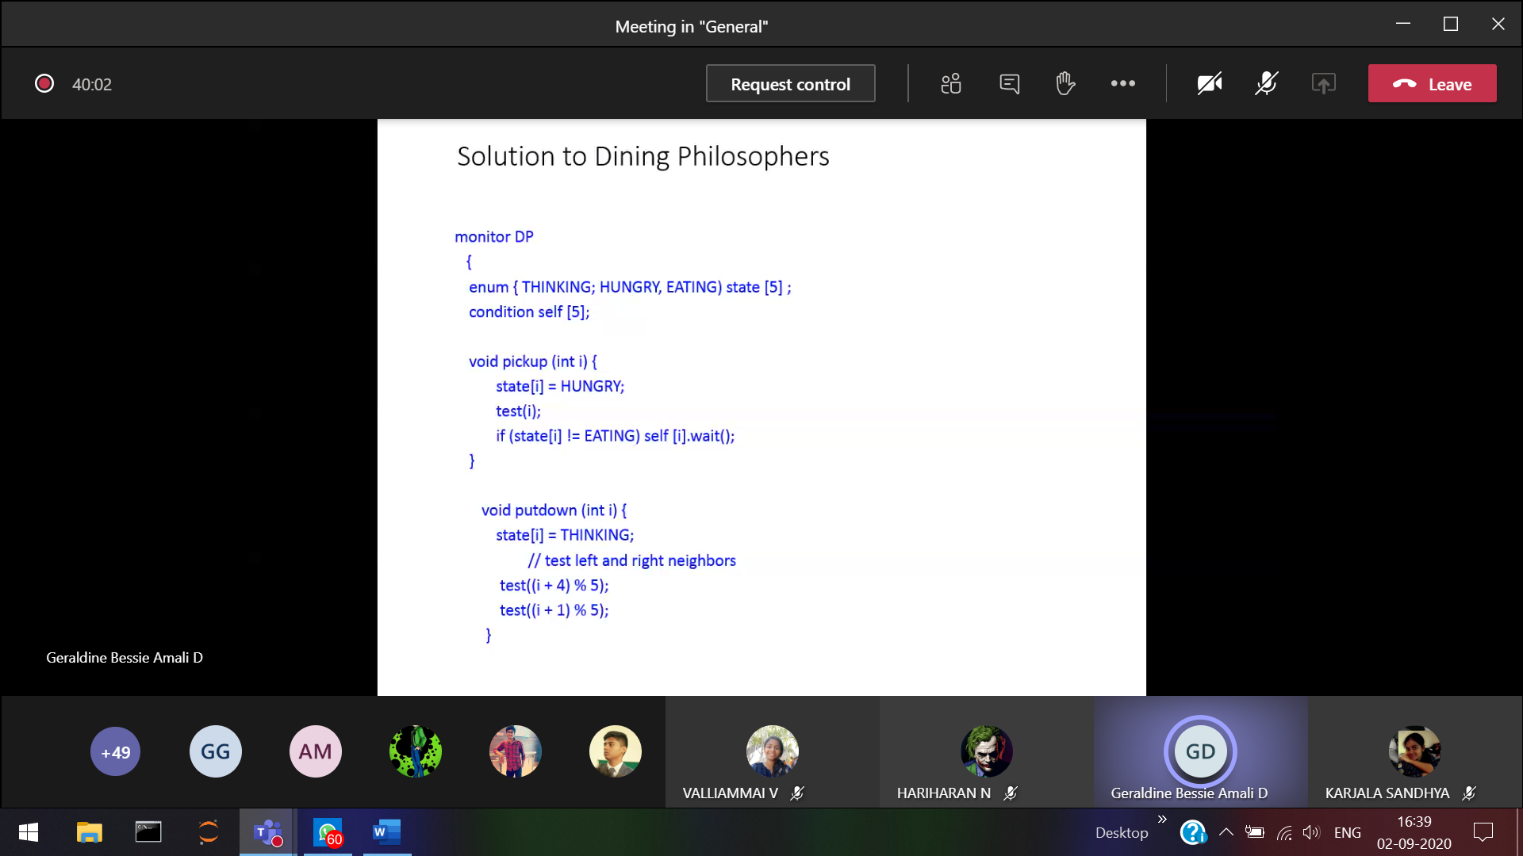

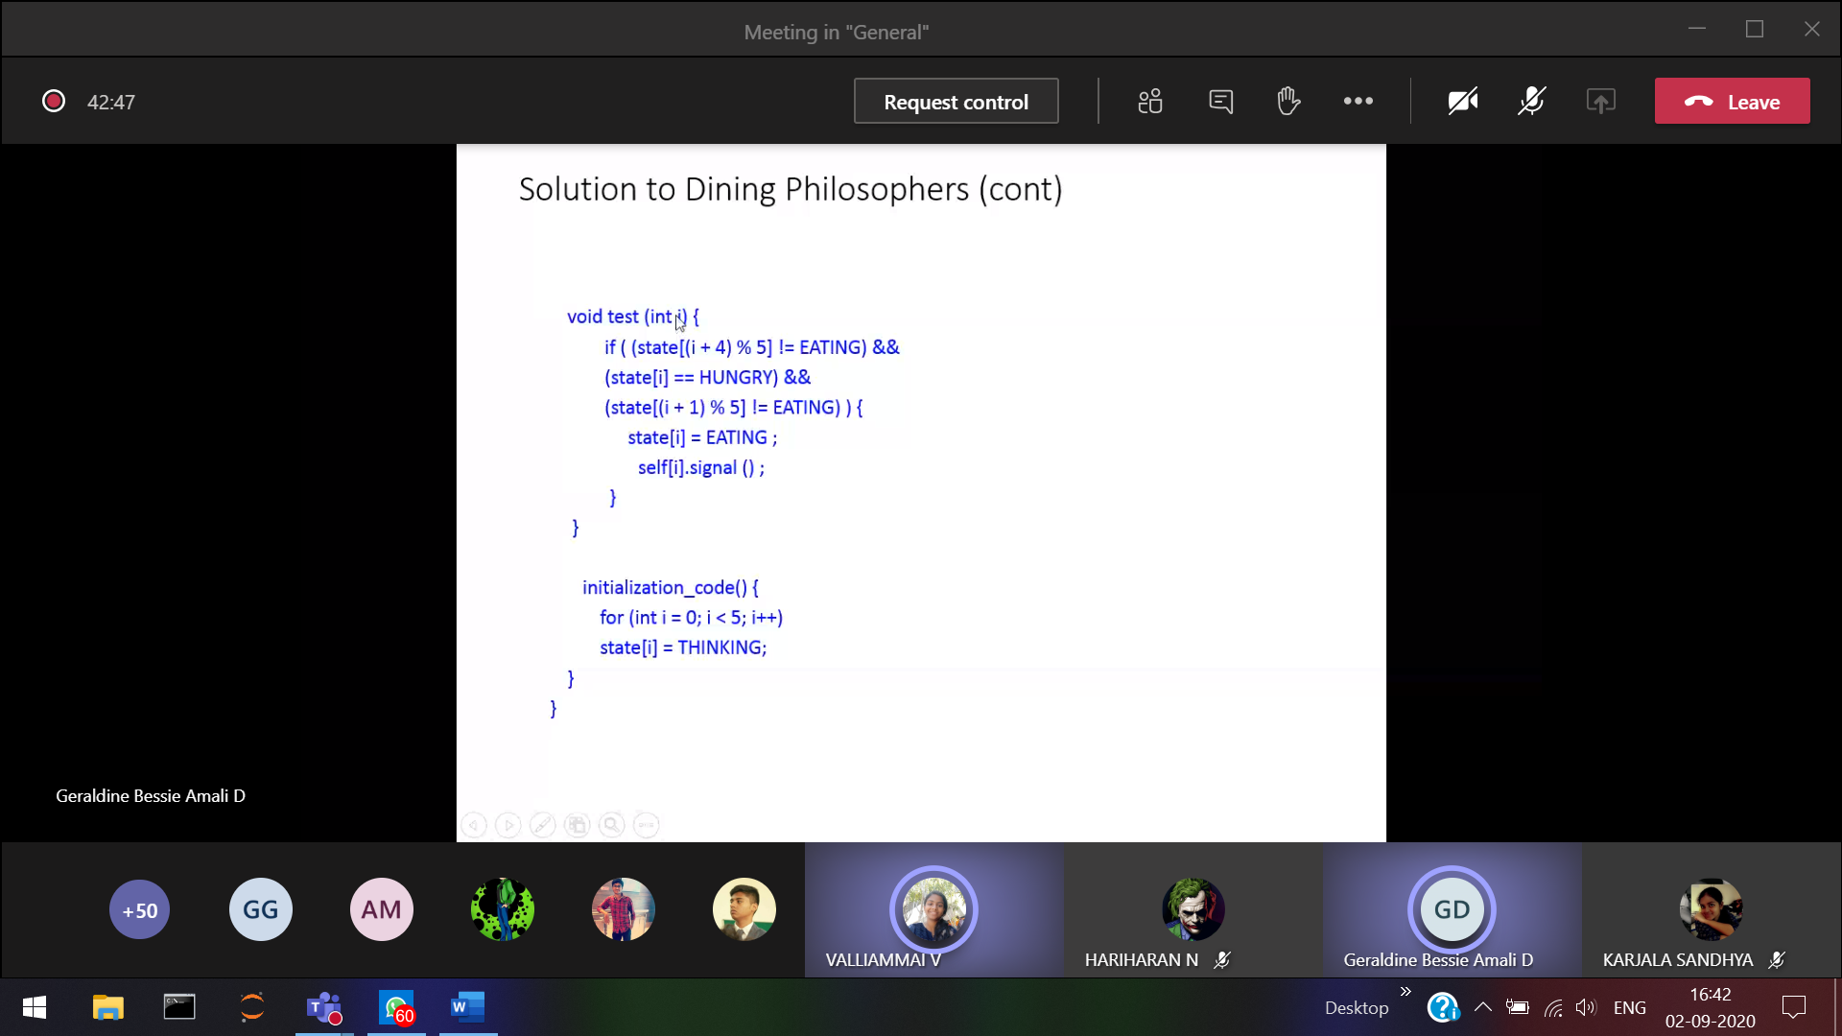

No chance for starvation.

**Dead lock condition:**   
When blocked processes hold on some resource and they wait for other resources which is being held by other blocked processes.

Eg: Simple scenario (b

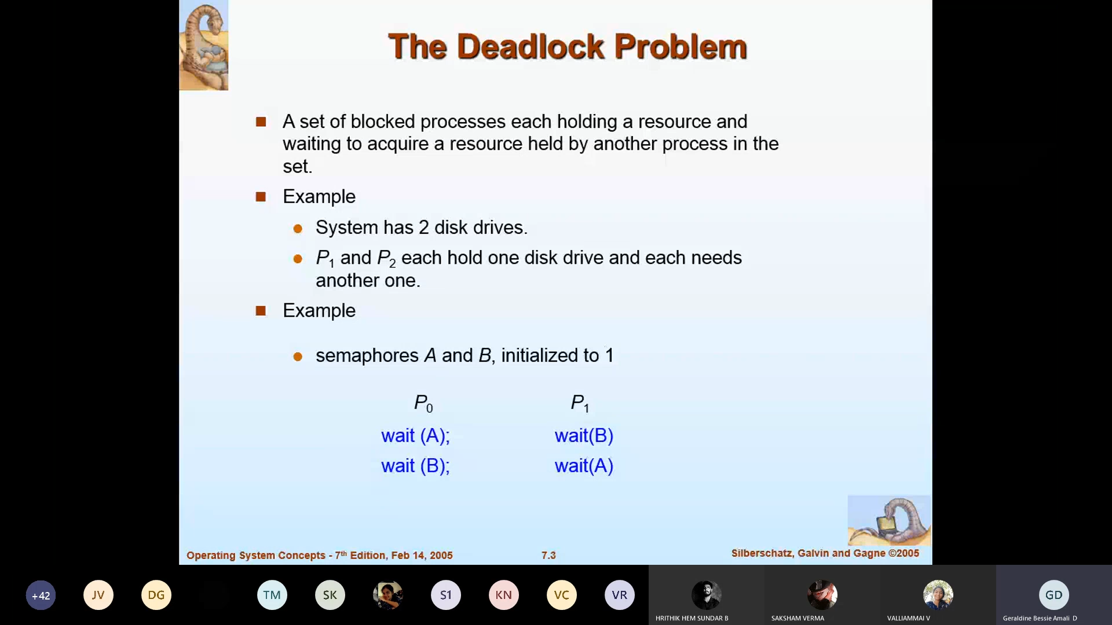

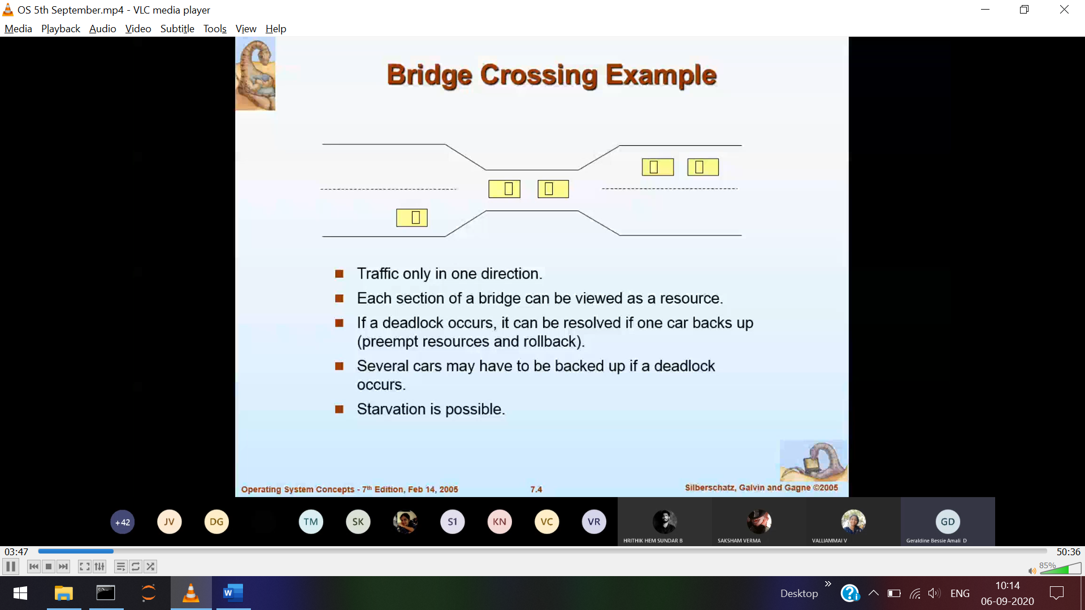

Dead lock condition in crossing the bridge.

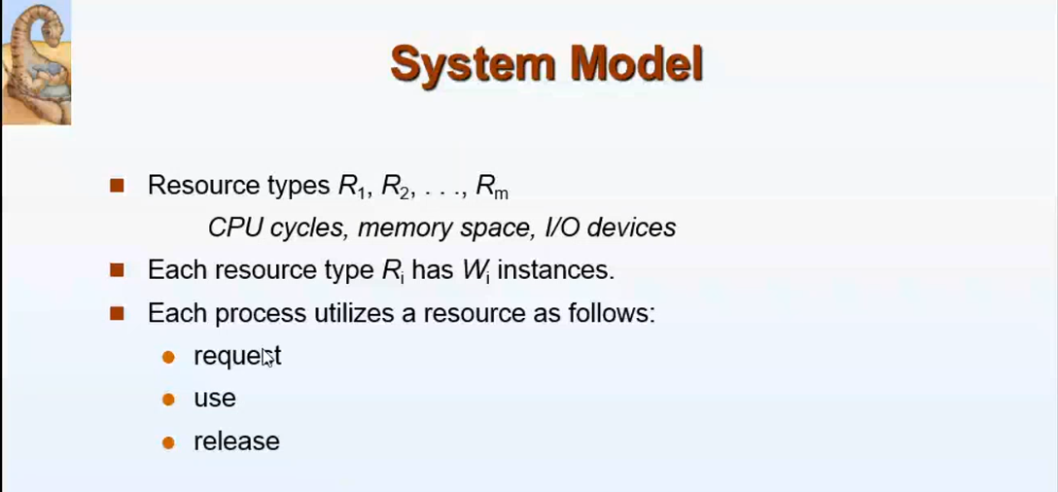

There are m resources in our PC.  
Every resources can be 1/every resource can have many instances.   
Eg: Quad core, octa core processes.

Every process should follow these three rules to use the resources.



Request use release



Problem start from here, the system holds in dead lock when these 4 conditions hold simultaneously.

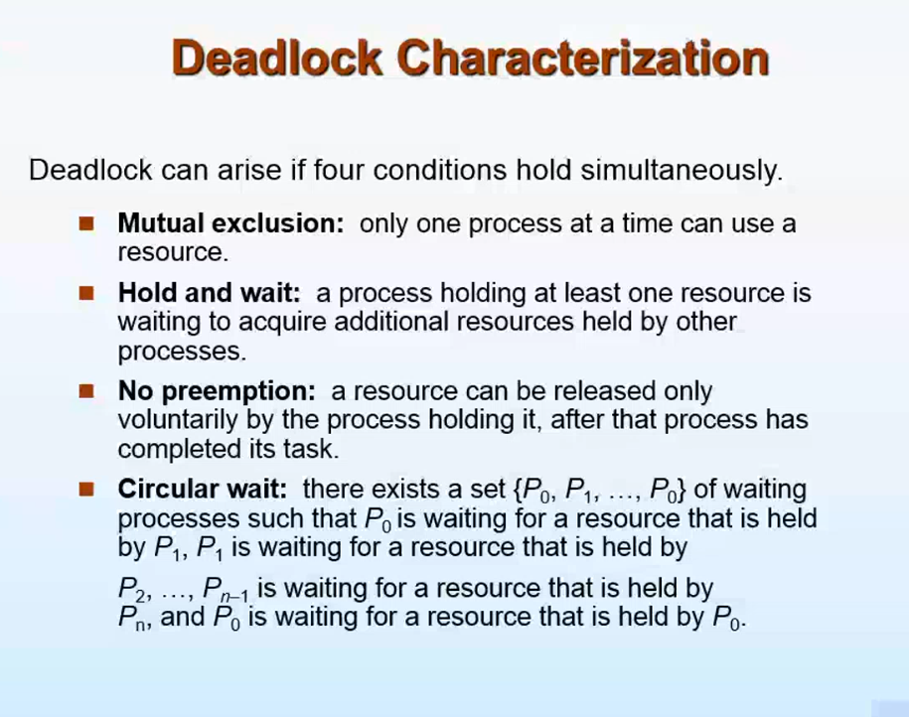

**Mutual exclusion** 🡪 Only 1 process can hold a resources at a particular time. A resource cannot be shared when a Process is holding that particular resource.  
(Similar to the critical section problem)

**Hold and wait**Me 🡪 holding (bat) waiting(ball)  
Brother 🡪 holding (ball) waiting(bat)

P0 🡪 holding R1 requesting R2  
P1 🡪 holding R2 requesting R1

**No pre-emption :**P1 🡪 Holding resource R1, This R1 cannot be taken forcibly and assign to P2. Once P1 completes the usage of R1 and releases, then only P2 can use R1

**Circular wait:**P1 🡪 holding R1 requesting R2  
P2 🡪 holding R2 requesting R3  
P3 🡪 holding R3 requesting R1



It moves in a circular fashion.

One way to find if a system has undergone deadlock 🡪 by means of resource allocation graph  
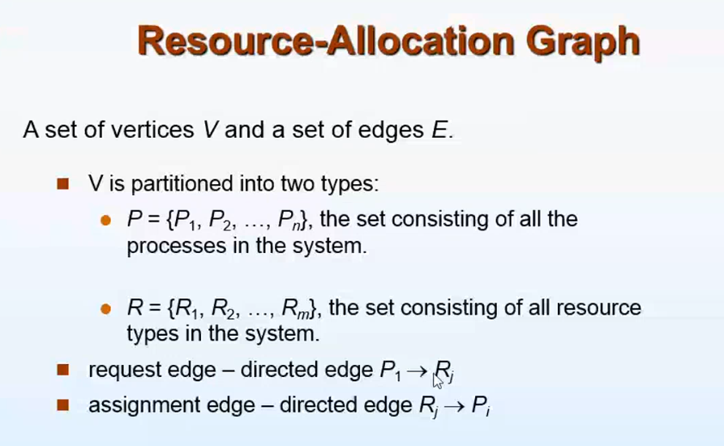

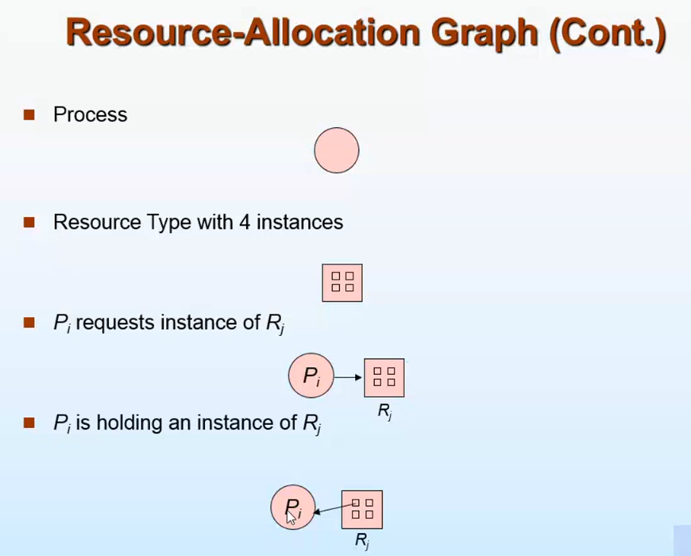

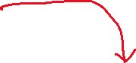

Request edge (from process to the resource)  
Assignment edge (assigns the whole resources to the process/assigns only a particular instance of the resource to the process)

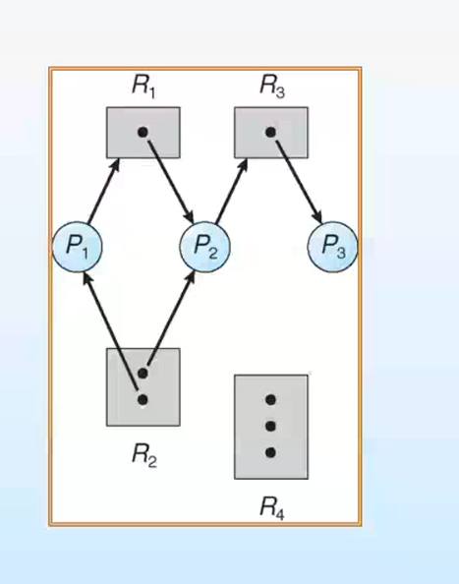

The dead lock condition is not there   
P3 is not requesting any resource and holding R3. After using R3, P3 releases R3  
So P2 which is requesting R3 will be granted and P2 uses one instance of R2 R3 and R1 and releases R1,R2 and R3.

Now P1 can easily uses one instance of R2 and R1, and releases both R1 and R2

How to convert a graph into deadlock condition

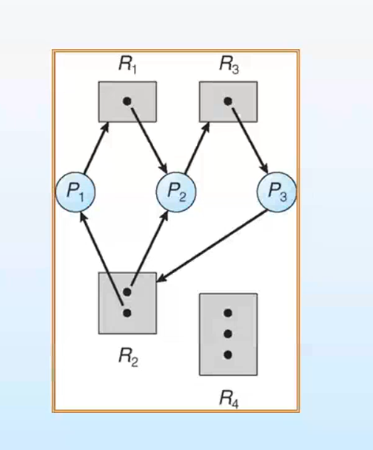



There is a cycle (and it is in deadlock). It is not necessary that if a cycle appears there is dead lock condition.



***Is the below graph a dead lock ???***

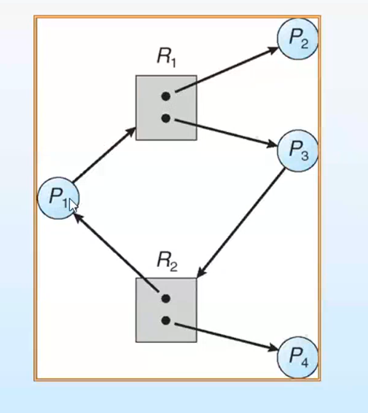

**No,** since P3 and P4 is having R3 and R2, P3 and P4 are not requesting anything. So P3 and P4 uses R3 and R2 and releases R3 and R2.  
***This is because there are multiple instance of R2 and R3, For eg: If there is only one instance of R3 and R2 🡪 Deadlock***

In the graph there is cycle, but not ends in dead lock.



SO it is clear that only cyclic condition is not enough to say that it ends in dead-lock. But if a dead lock is there, definitely there will be a cycle.



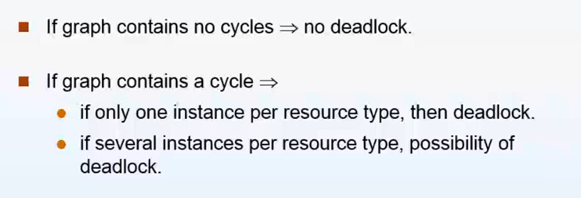

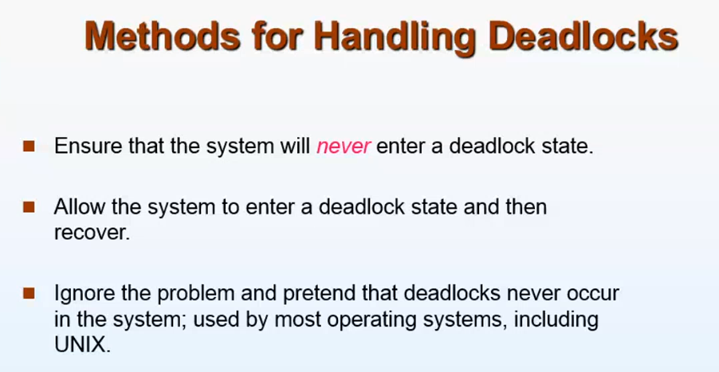

**1)Prevent deadlock  
2) Allow the system to enter into deadlock and recover it  
3) Simply Switch OFF when the system freezes. So that all the process in RAM will be erased and start from the first.**

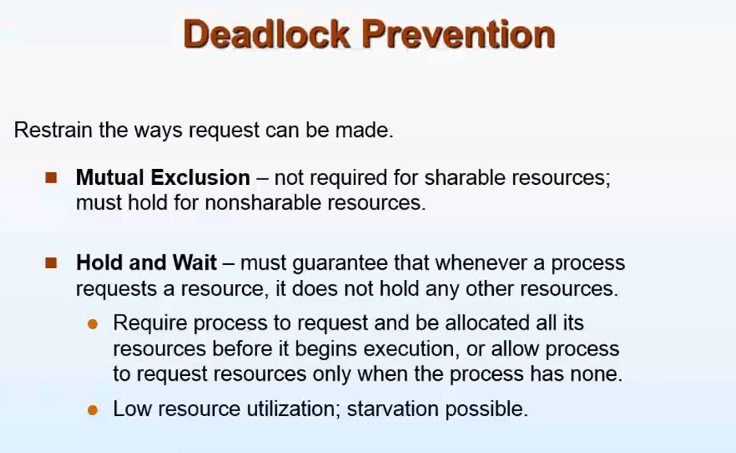

**Hold and wait :**

P1) Me 🡪 holding (bat) waiting(ball)  
P2) Brother 🡪 holding (ball) waiting(bat)

If P1 leaves the bat P2 acquires the bat and go to play. After P1 leaves the bat, it has to request the bat once again to use it.   
But P1 don’t know when P2 will come back , so P2 starves for a long time.

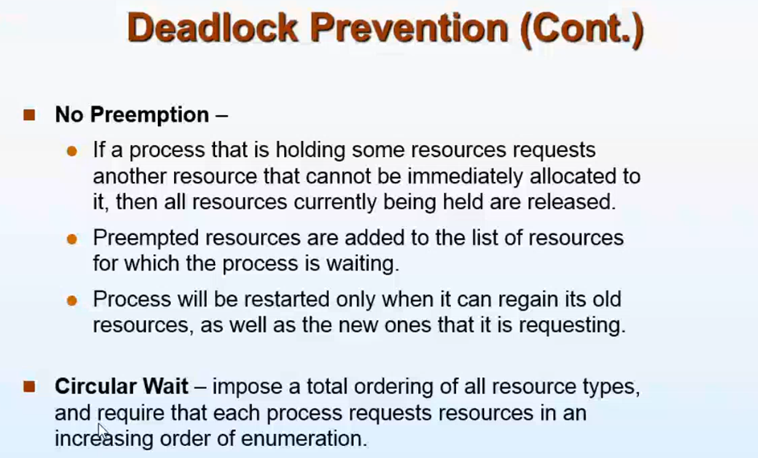

**No Pre-emption:**

P1 holding R1 . P2 requesting R1, so P2 forcibly remove R1. Once again P1 should request R1 to use it.  
This also leads to low utilization and starvation.   
(Higher priority process 🡪 More preference and   
lower priority process 🡪 Less preference)  
This approach is practical only when applied to resources whose state can be

easily saved and restored later, as is the case with a processor.

**Circular wait**

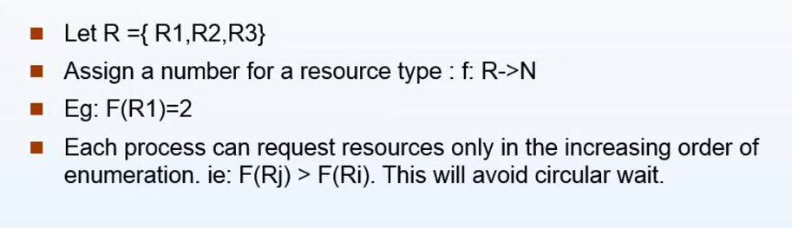

**Each process should request the resource in the increasing order of enumeration**

**A process which has acquired a larger number will never go ahead and acquire the process with the smallest number**

P1 R1 🡪 2  
 R2 🡪 3  
 R3 🡪 4



R1 🡪 2 (2>3)  
 R2 🡪 3 (3>4)  
P2 R3 🡪 4



P2 should release R3 and then only it can use R1 and R2/ P2 can use R4.

P2 R3 🡪 4  
 R4 🡪 5



The Above conditions (Prevention of deadlock) are not at all possible.   
So another approach  
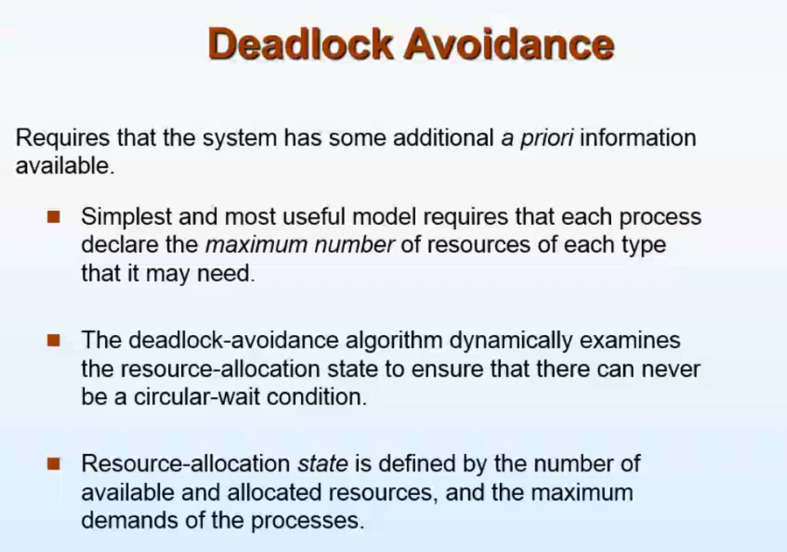

Father,mother,me,sister   
Available resources 🡪 A car and a bike   
**Someone wants to go out(No car, no bike) 🡪 Dead lock**

***Brother gone out with bike. If father gets a phone call from office he want to immediately go to office with car.***

* If I ask the car to go out, even if the car is available my father won’t give it to me unless my brother returns.
* Since if I take the car out and the phone call comes 🡪 Father can’t go out(dead lock)

Like this as soon as the process requests the resource OS immediately won’t give it, It checks after giving this resource whether it will end in deadlock/not. If not it will give.

In dead-lock avoidance, every process must declare the maximum number of resources it needs (from start to end)

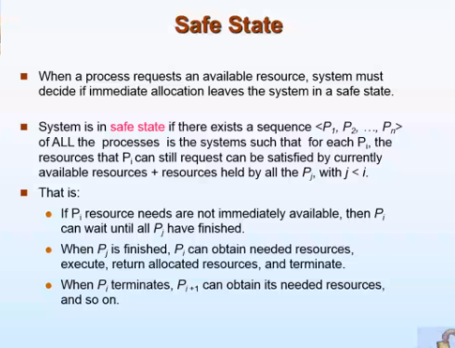

Out of all process, first see whose needs can be satisfied with the available resource  
P1,P2,P3,P4  
P1(first process) 🡪 available resources   
P2 🡪 P1(holding) + available resources  
P3 🡪 P1(holding) + P2(holding) + available resources

These ordering can differ

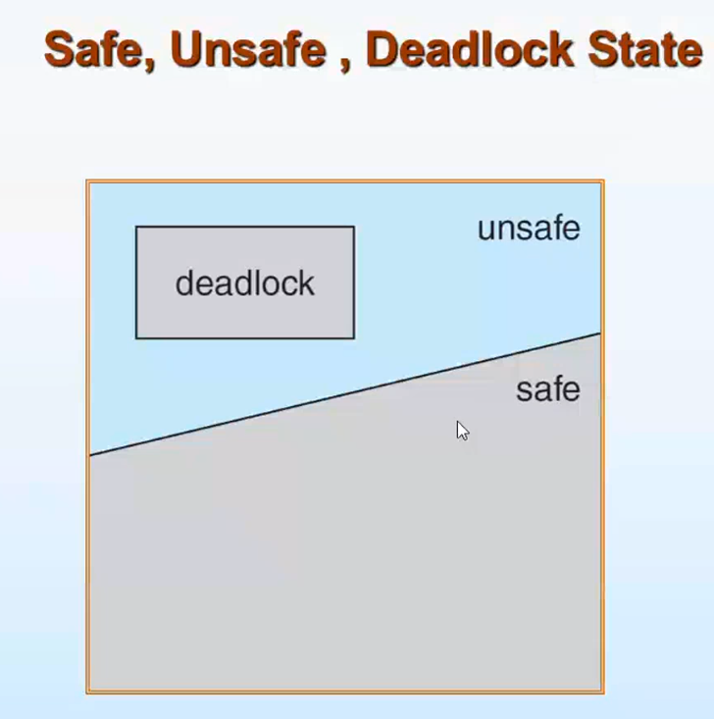

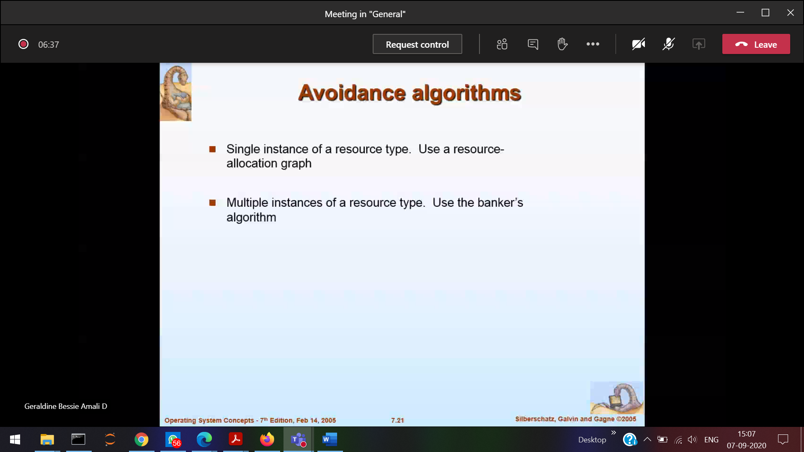

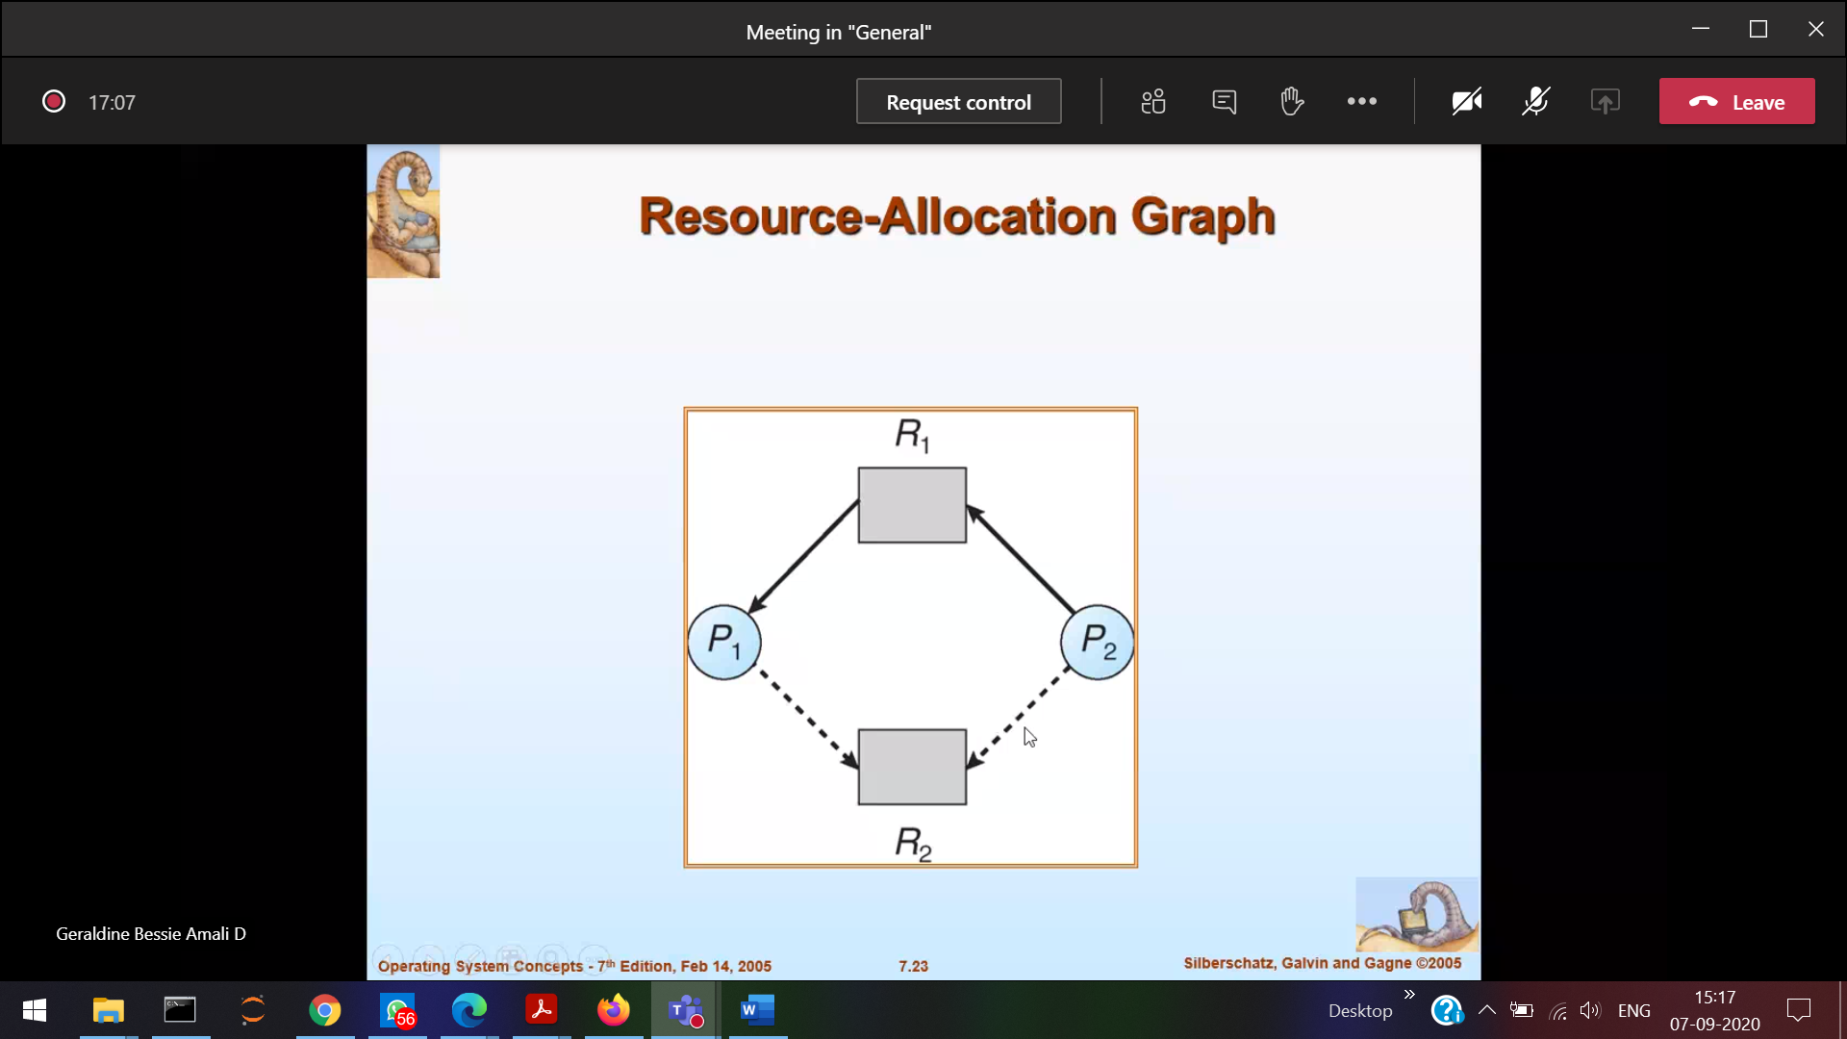

After some time P1 and P2 requires R2

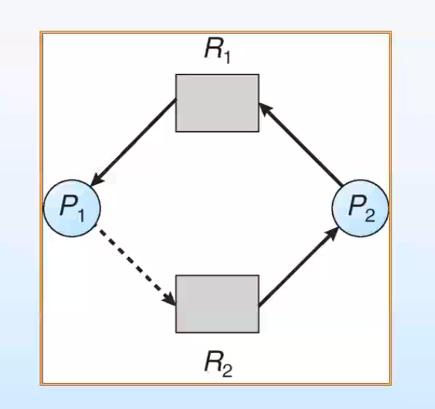

Dead lock(circle) [When R2 is allocated for P2]

Even though R2 available it will not grant (Check if deadlock happens)

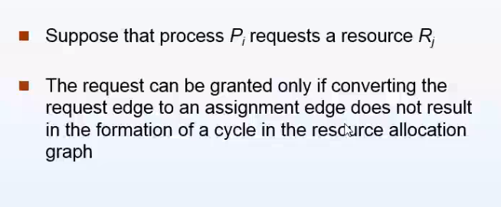

­­

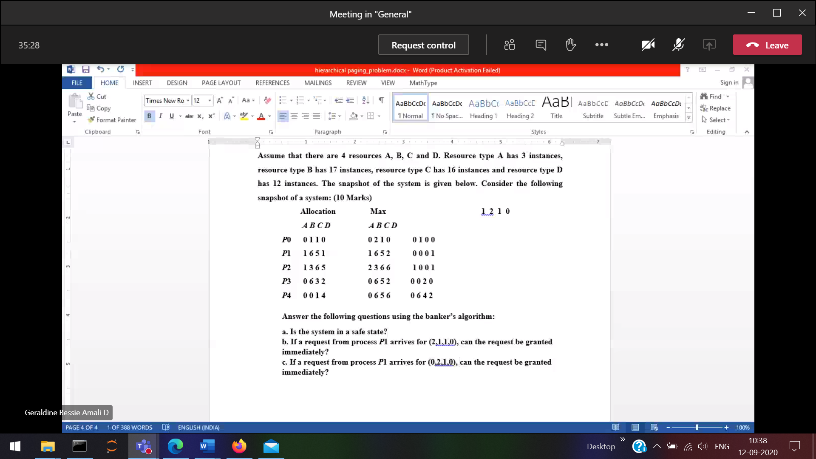

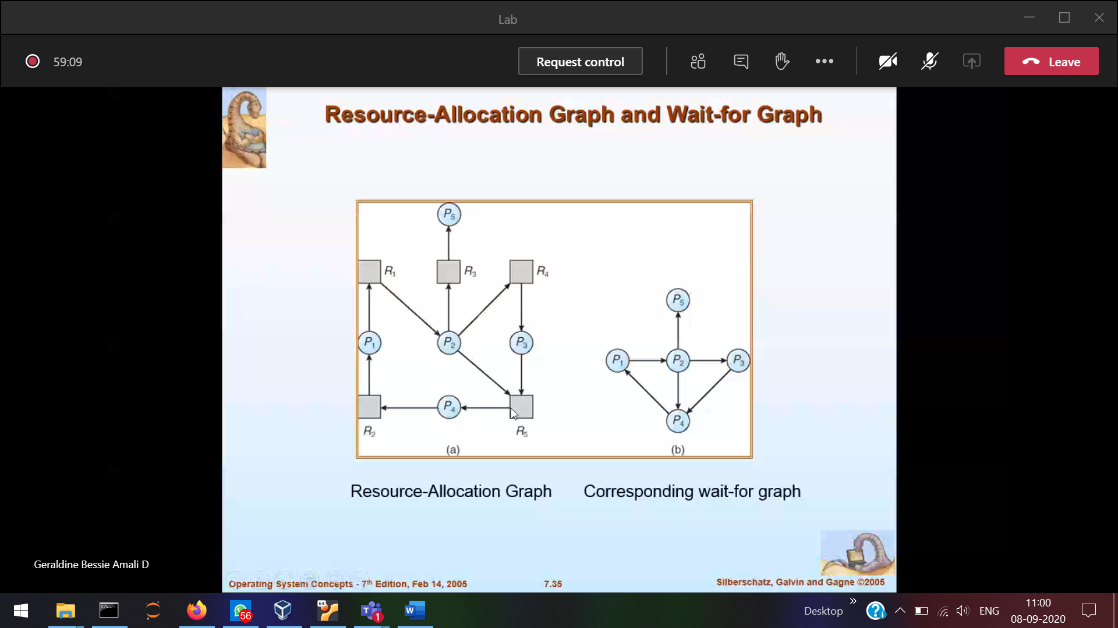

All the resources are removed in wait-for graph

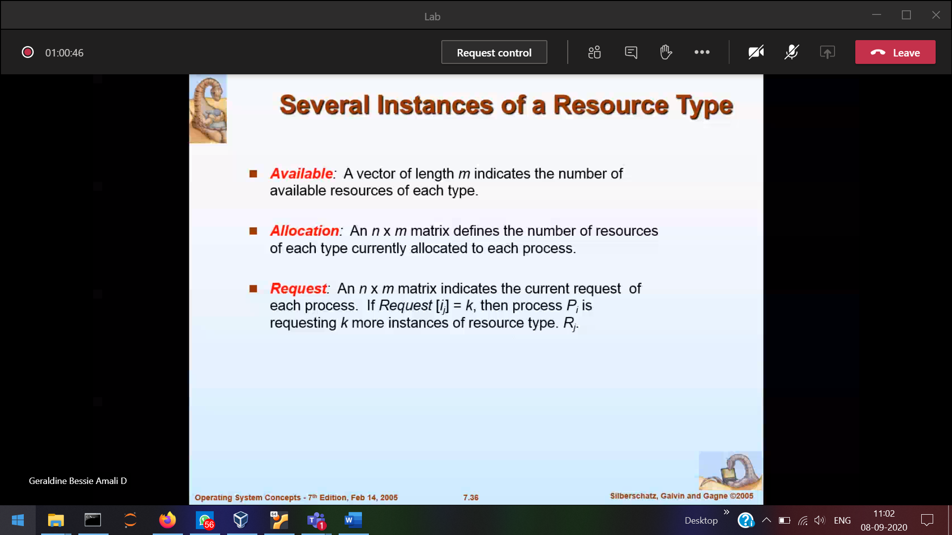

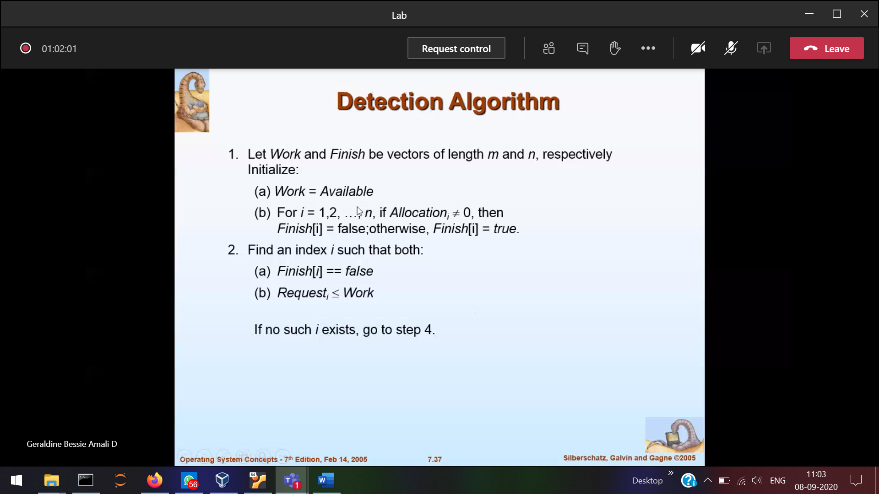

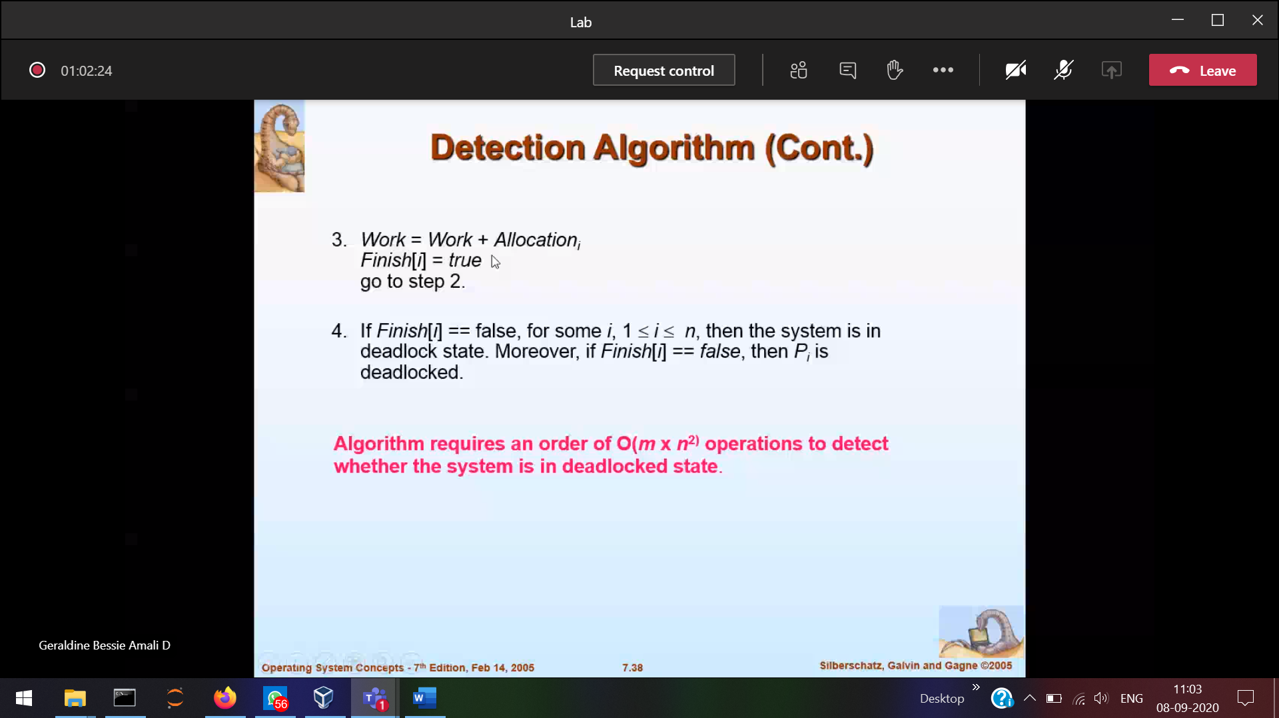

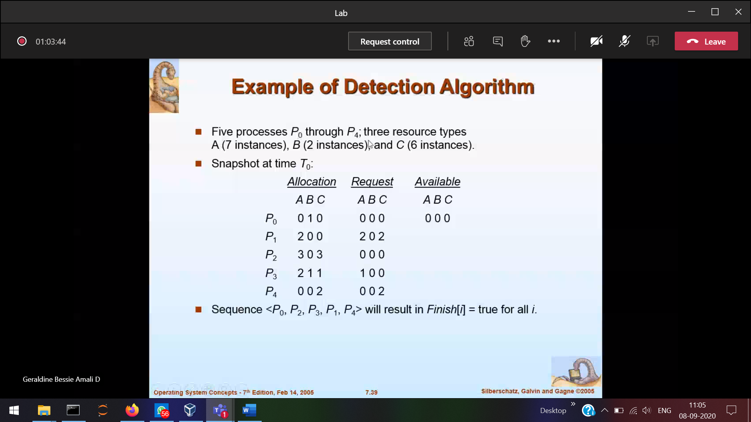

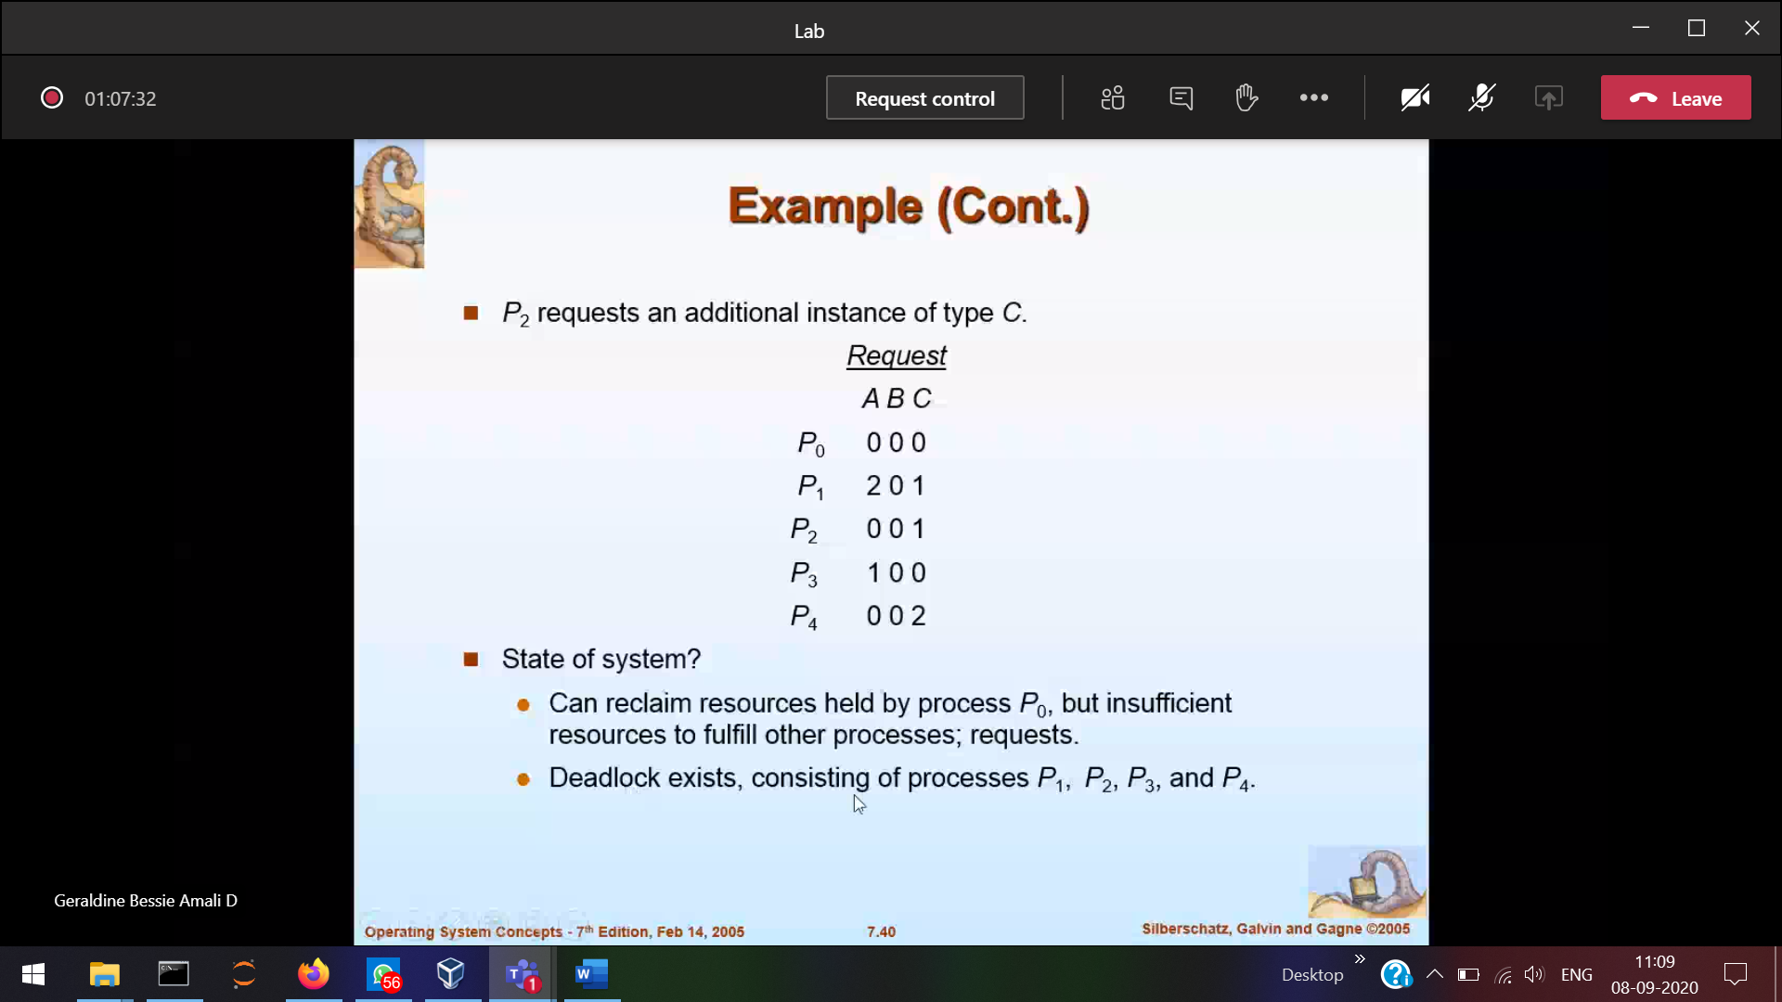

After deadlock what will you do

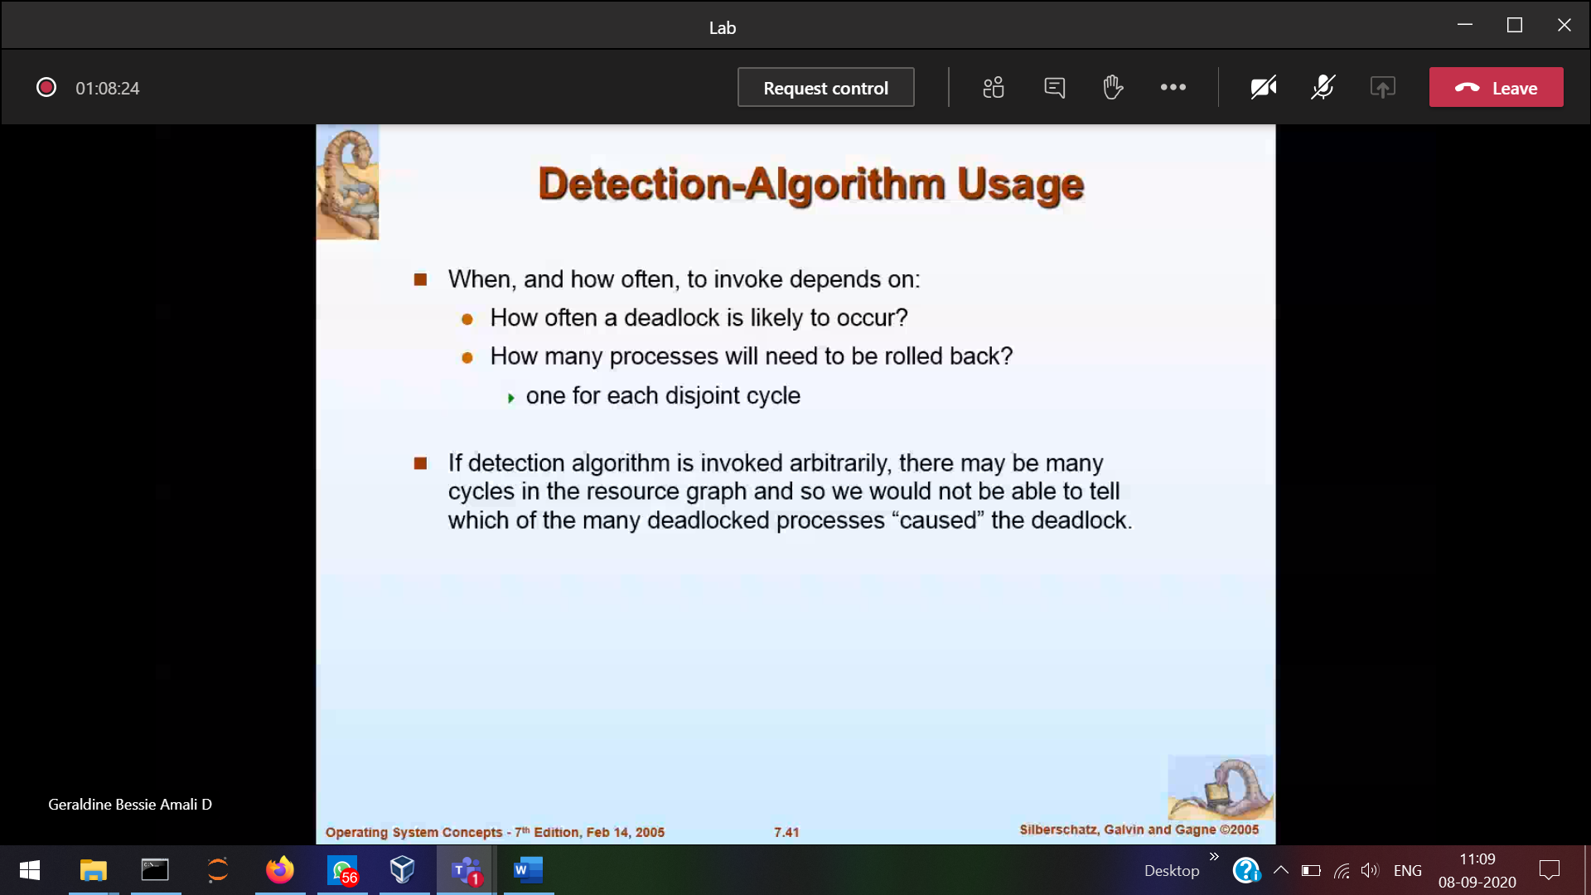

Should recover from deadlock

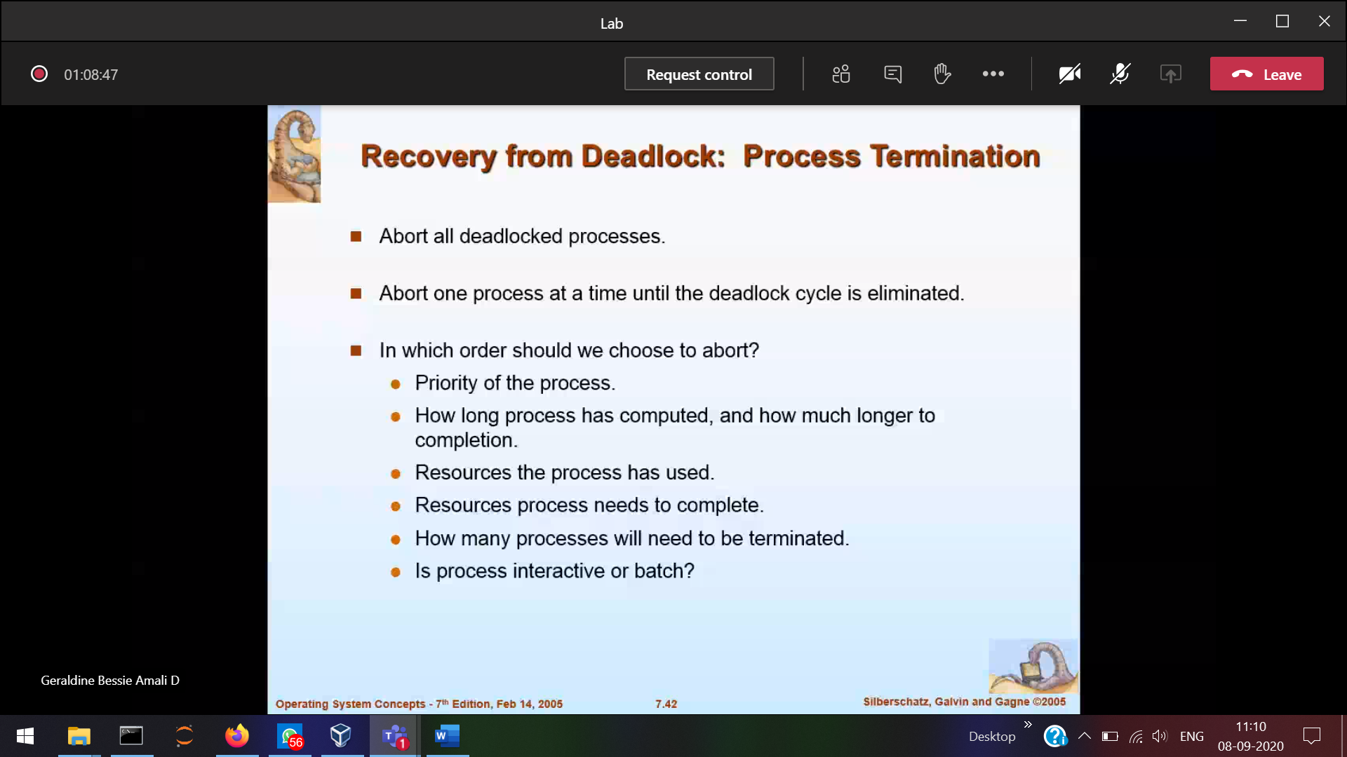

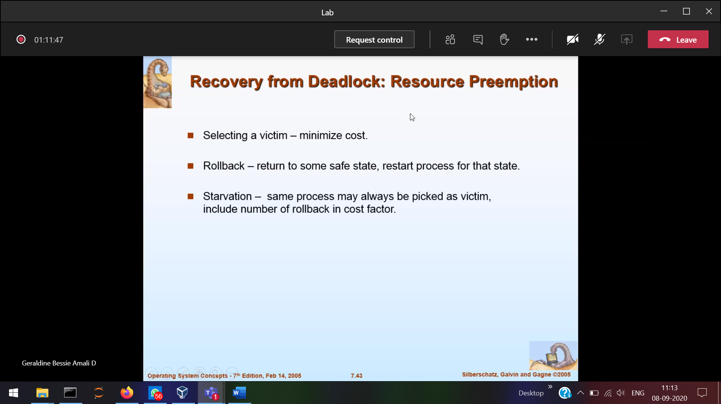

These are very extra work

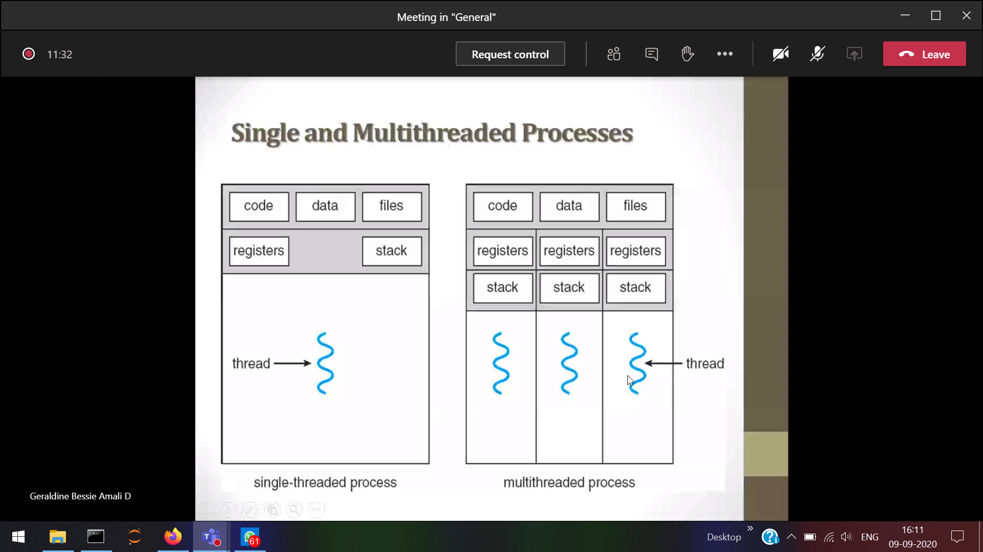

Single thread 1 process 🡪1 thread (if gone in blocked state) then other process should wait

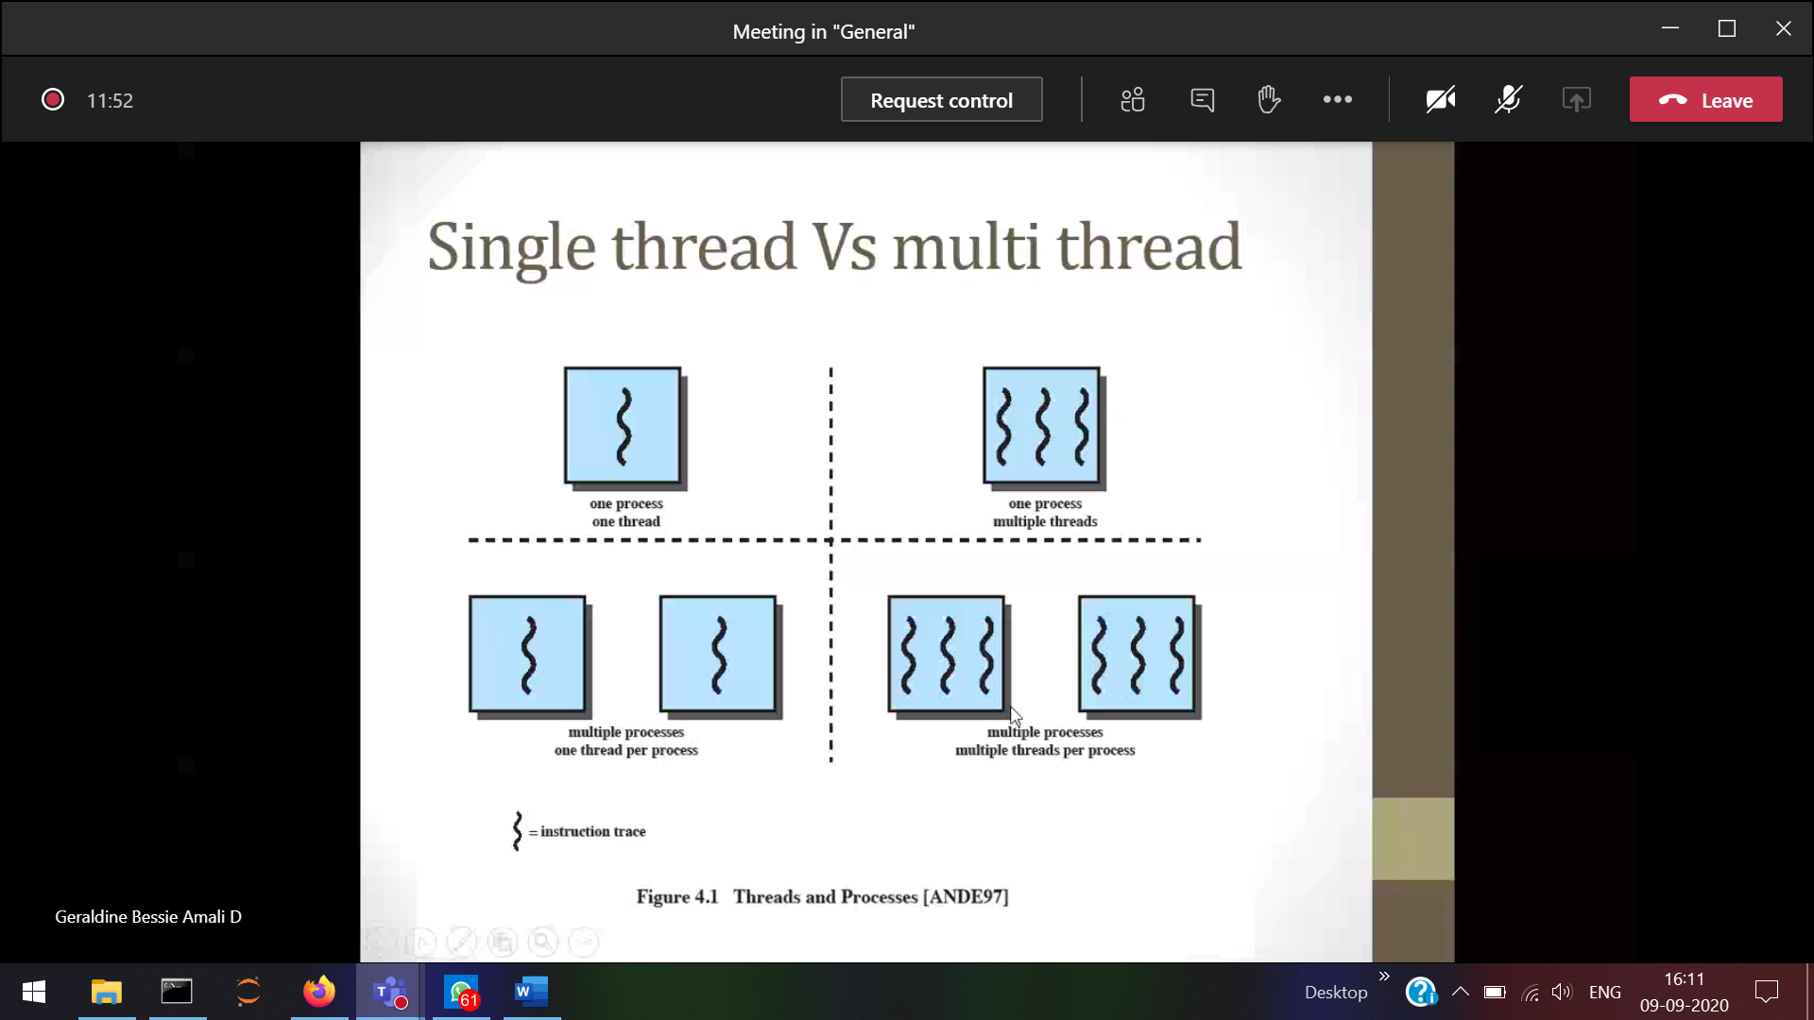­

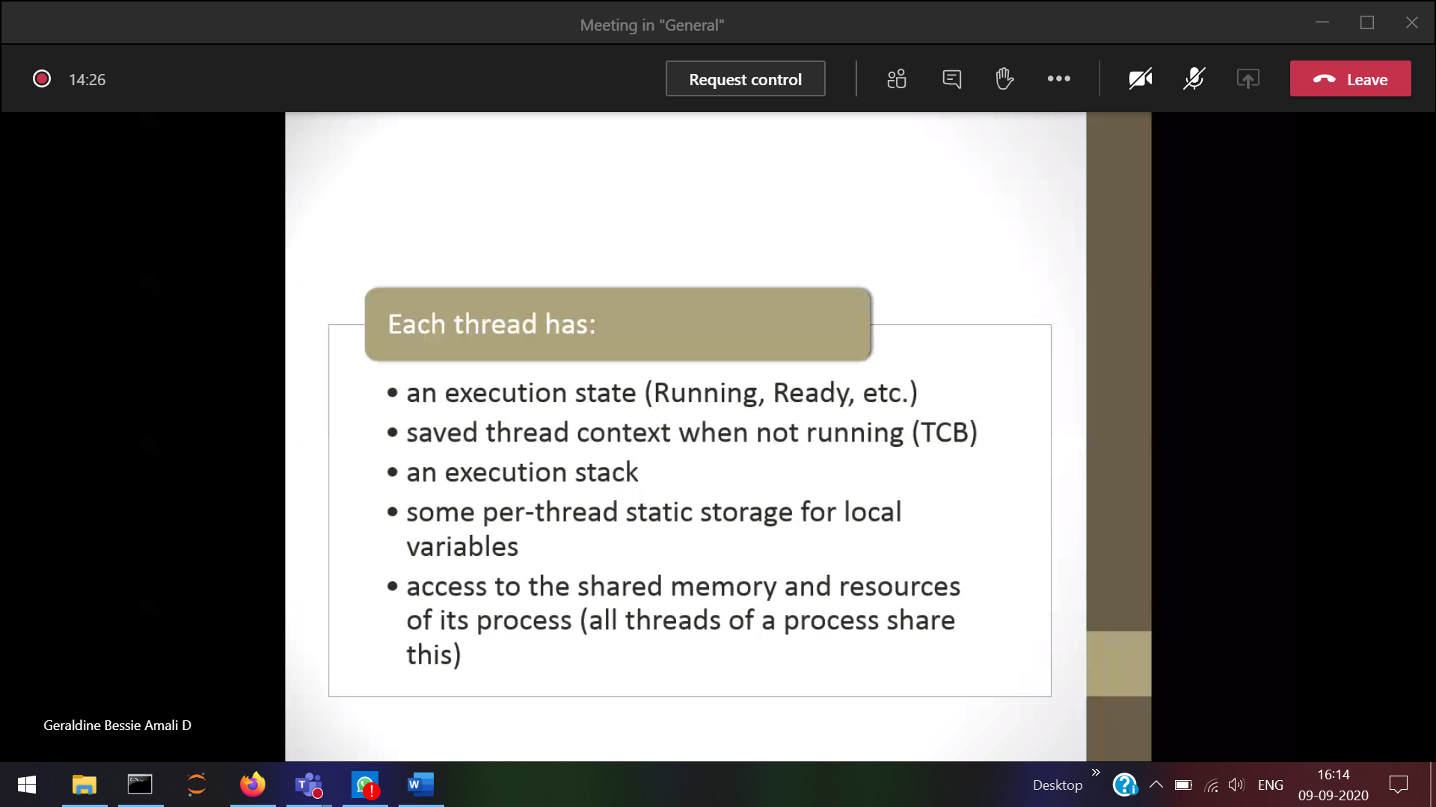

1 process 🡪 PCB 🡪 Multiple thread . Each and every thread will have its own PCB.

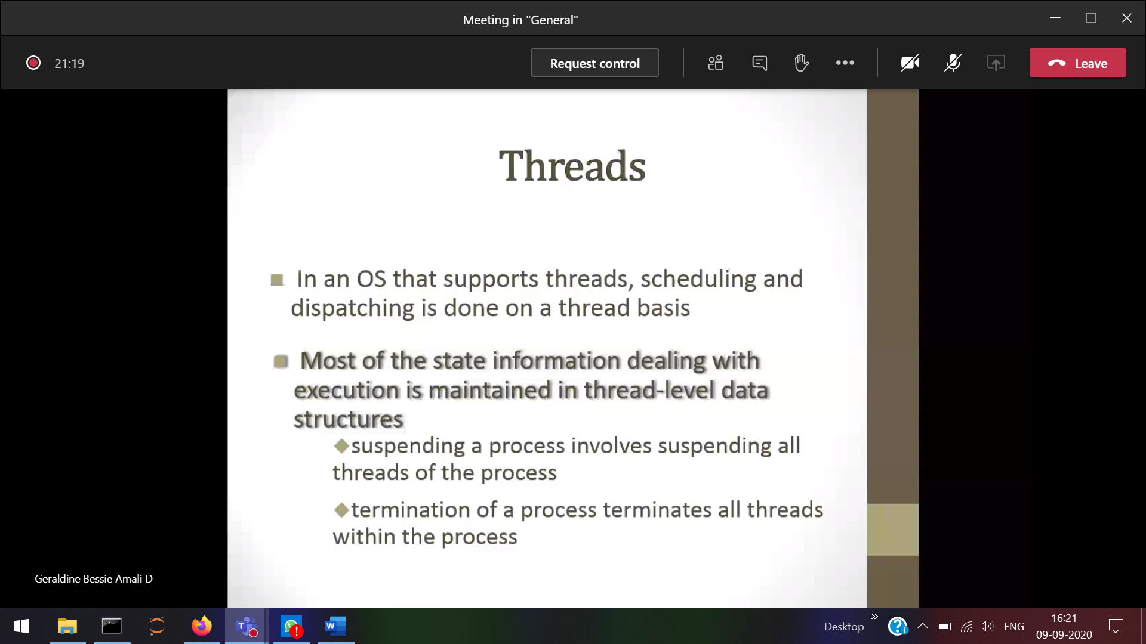If a process terminates then its respective threads will also be terminated

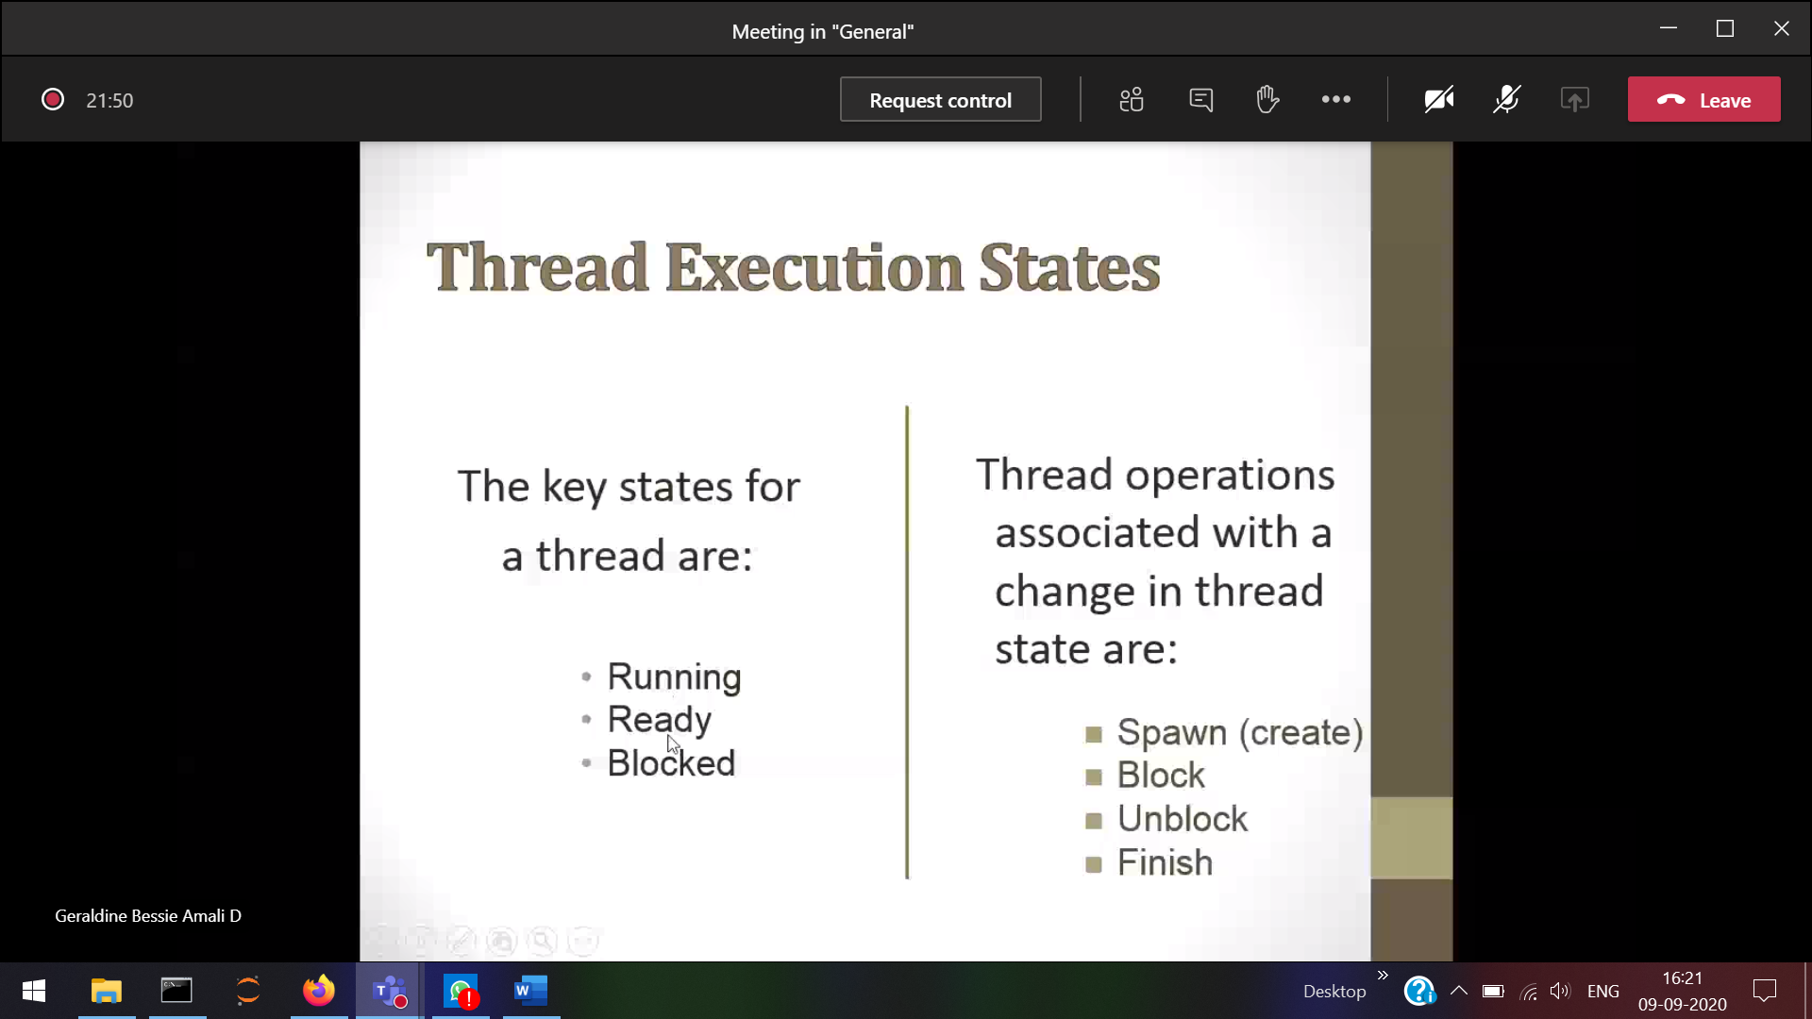

A thread can create another thread.  
A thread can block/unblock itself

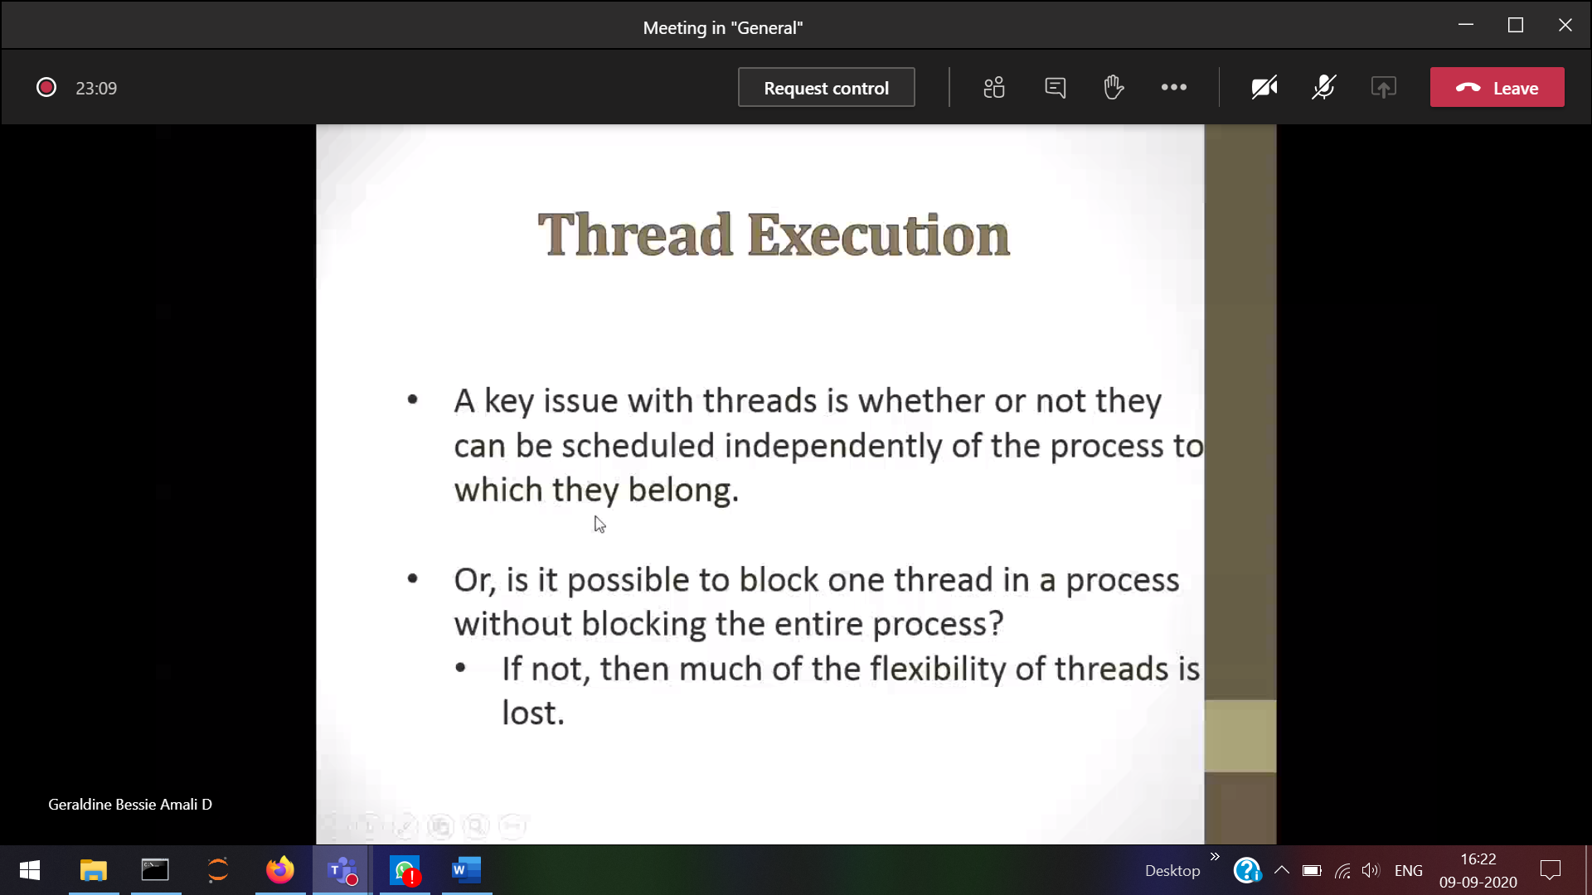

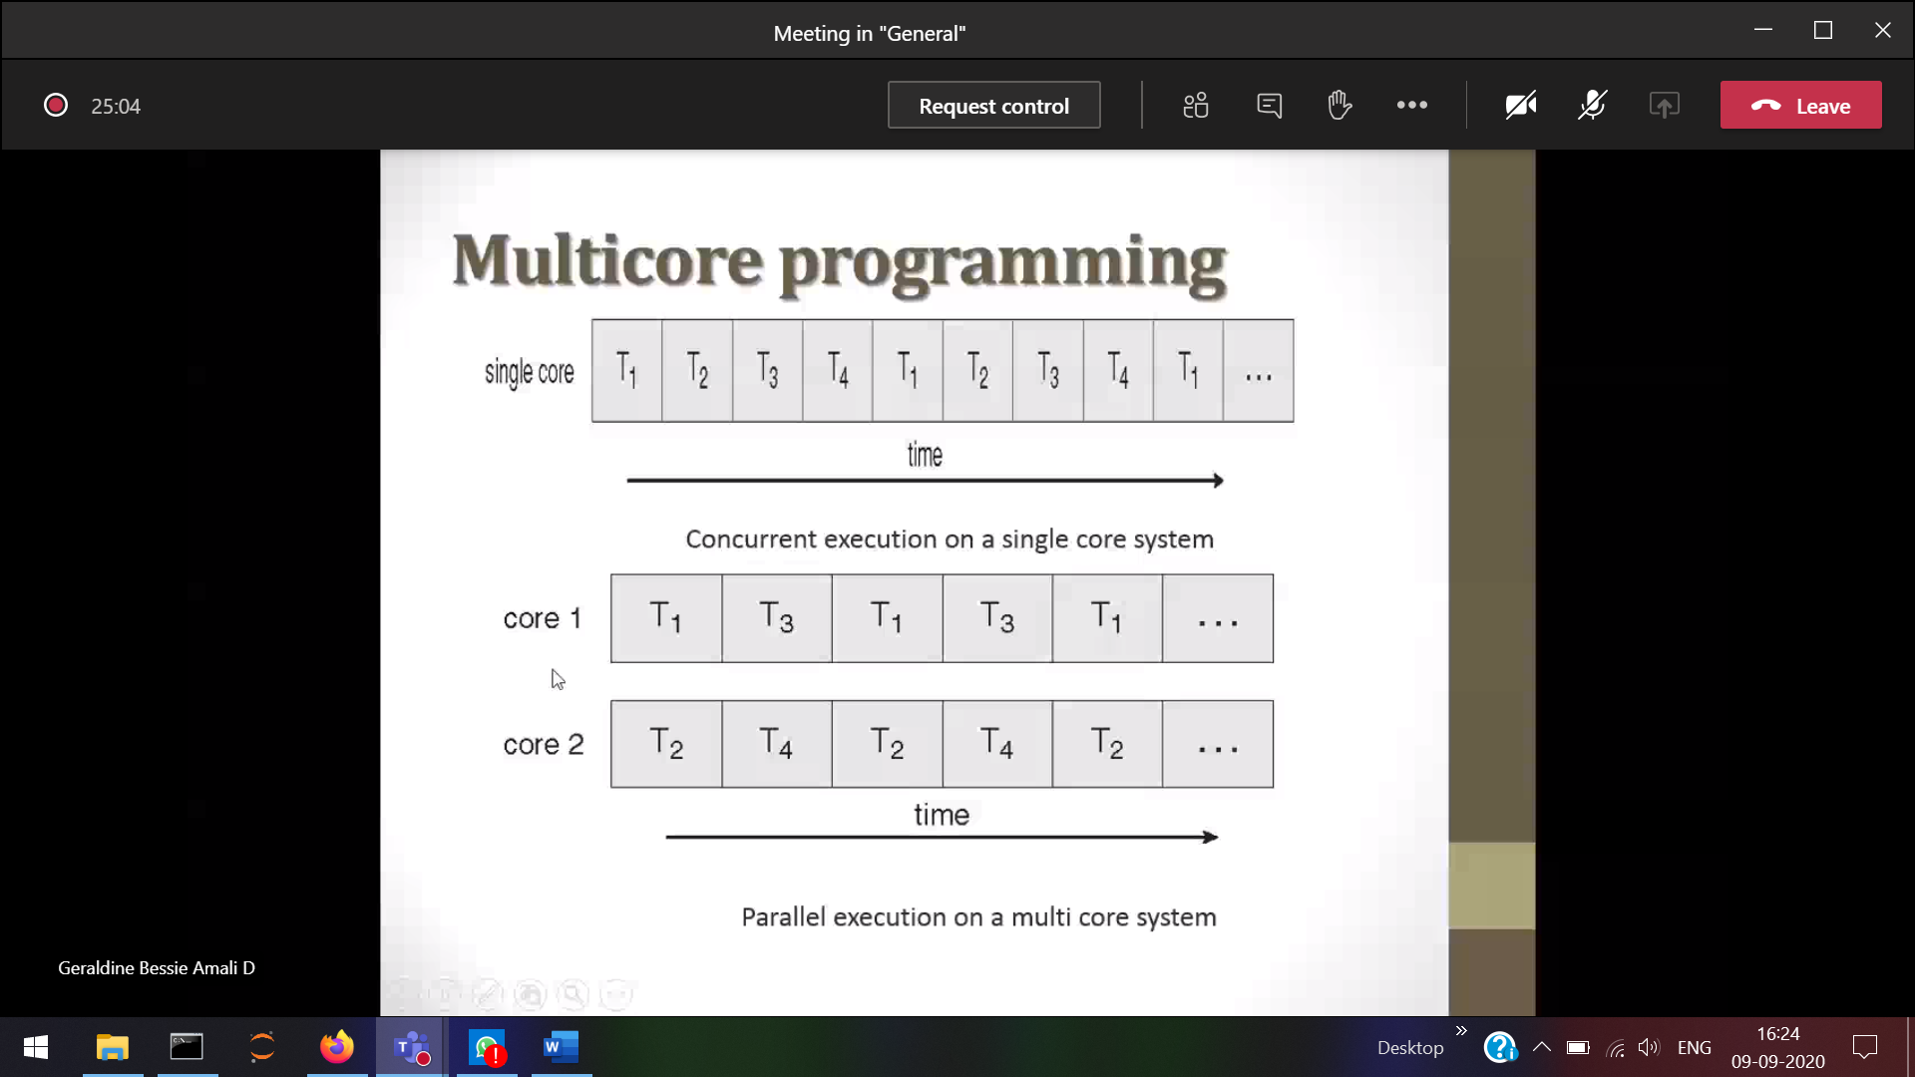

Single core 🡪 One process at a time

Multi-core 🡪 the threads can be scheduled

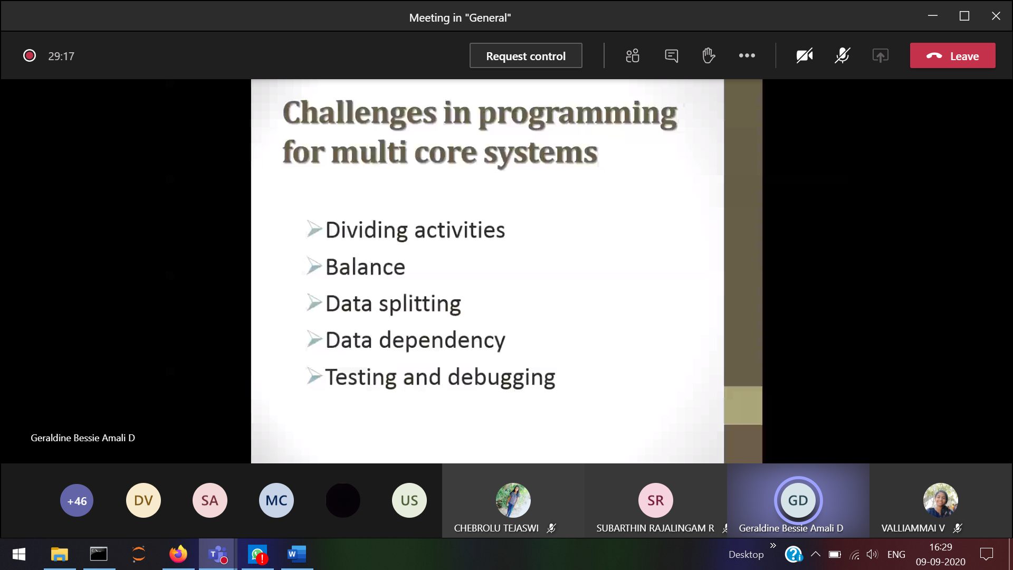

Crct balance must be done between the threads

Data dependency 🡪 1 thread should wait for the output of another thread

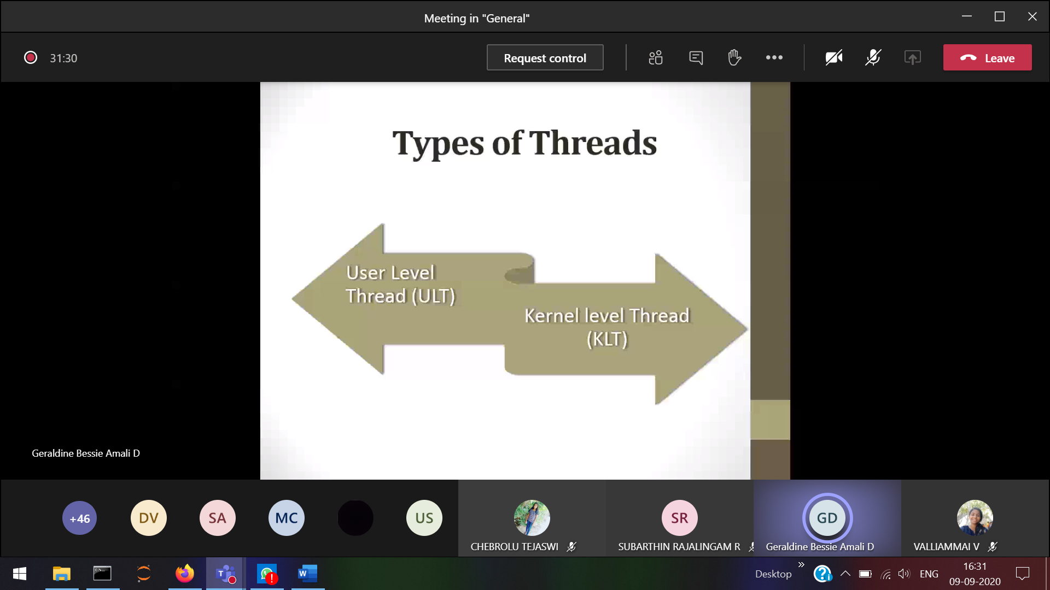

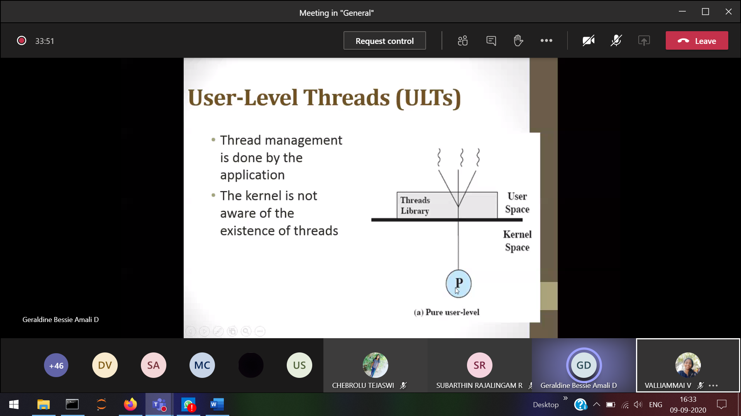

OS will look as a single process (actually thread is running)

Thread switiching takes place in the user mode itself, no required for kernel mode. Only 1 thread can execute at a time

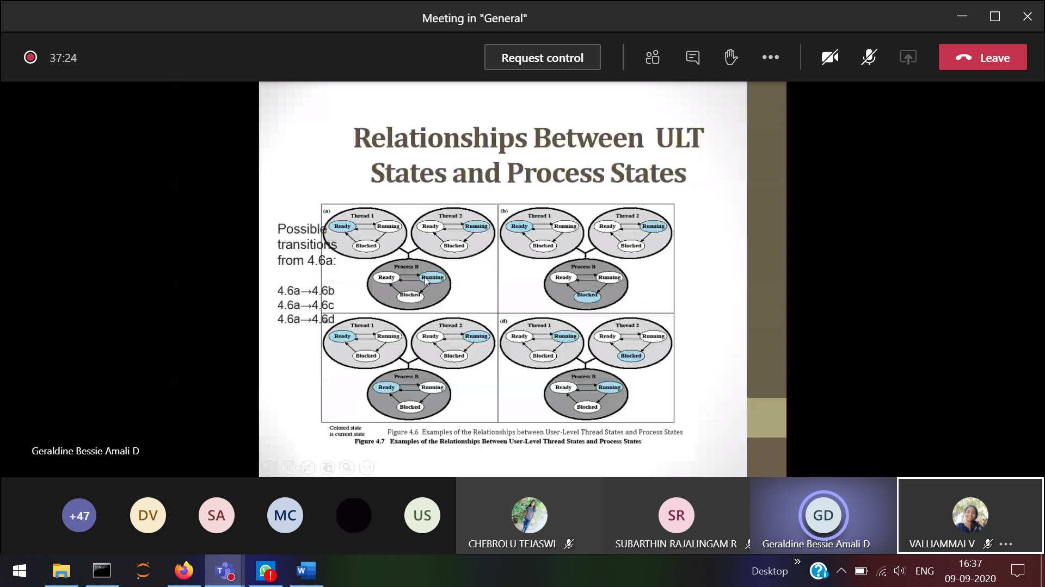

1. 2) P is blocked **3) P is running**

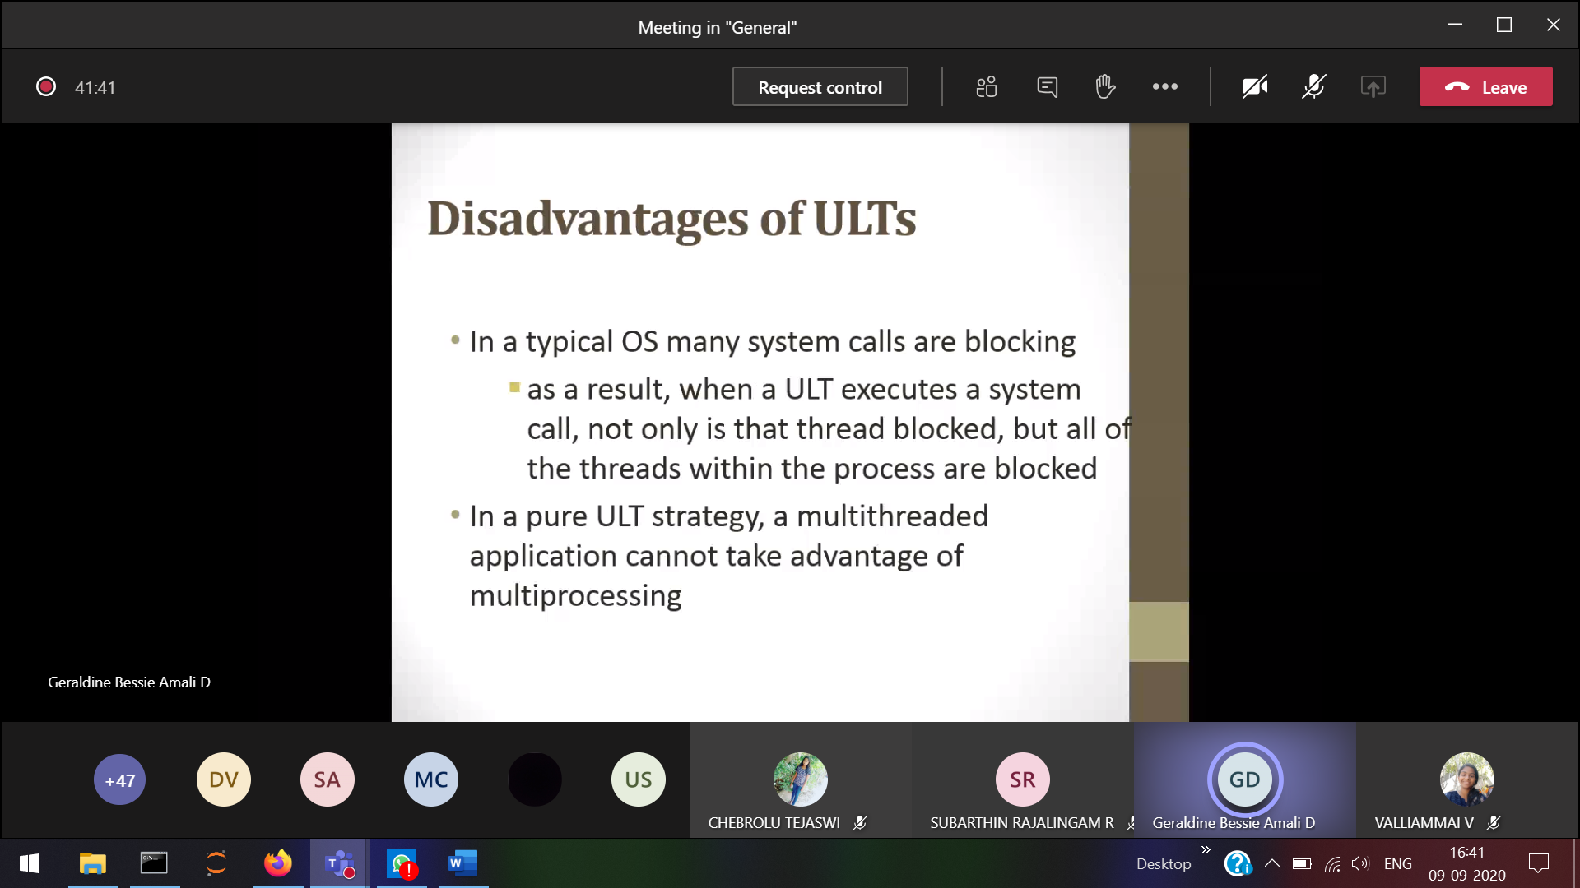ULT cannot use multiple cores

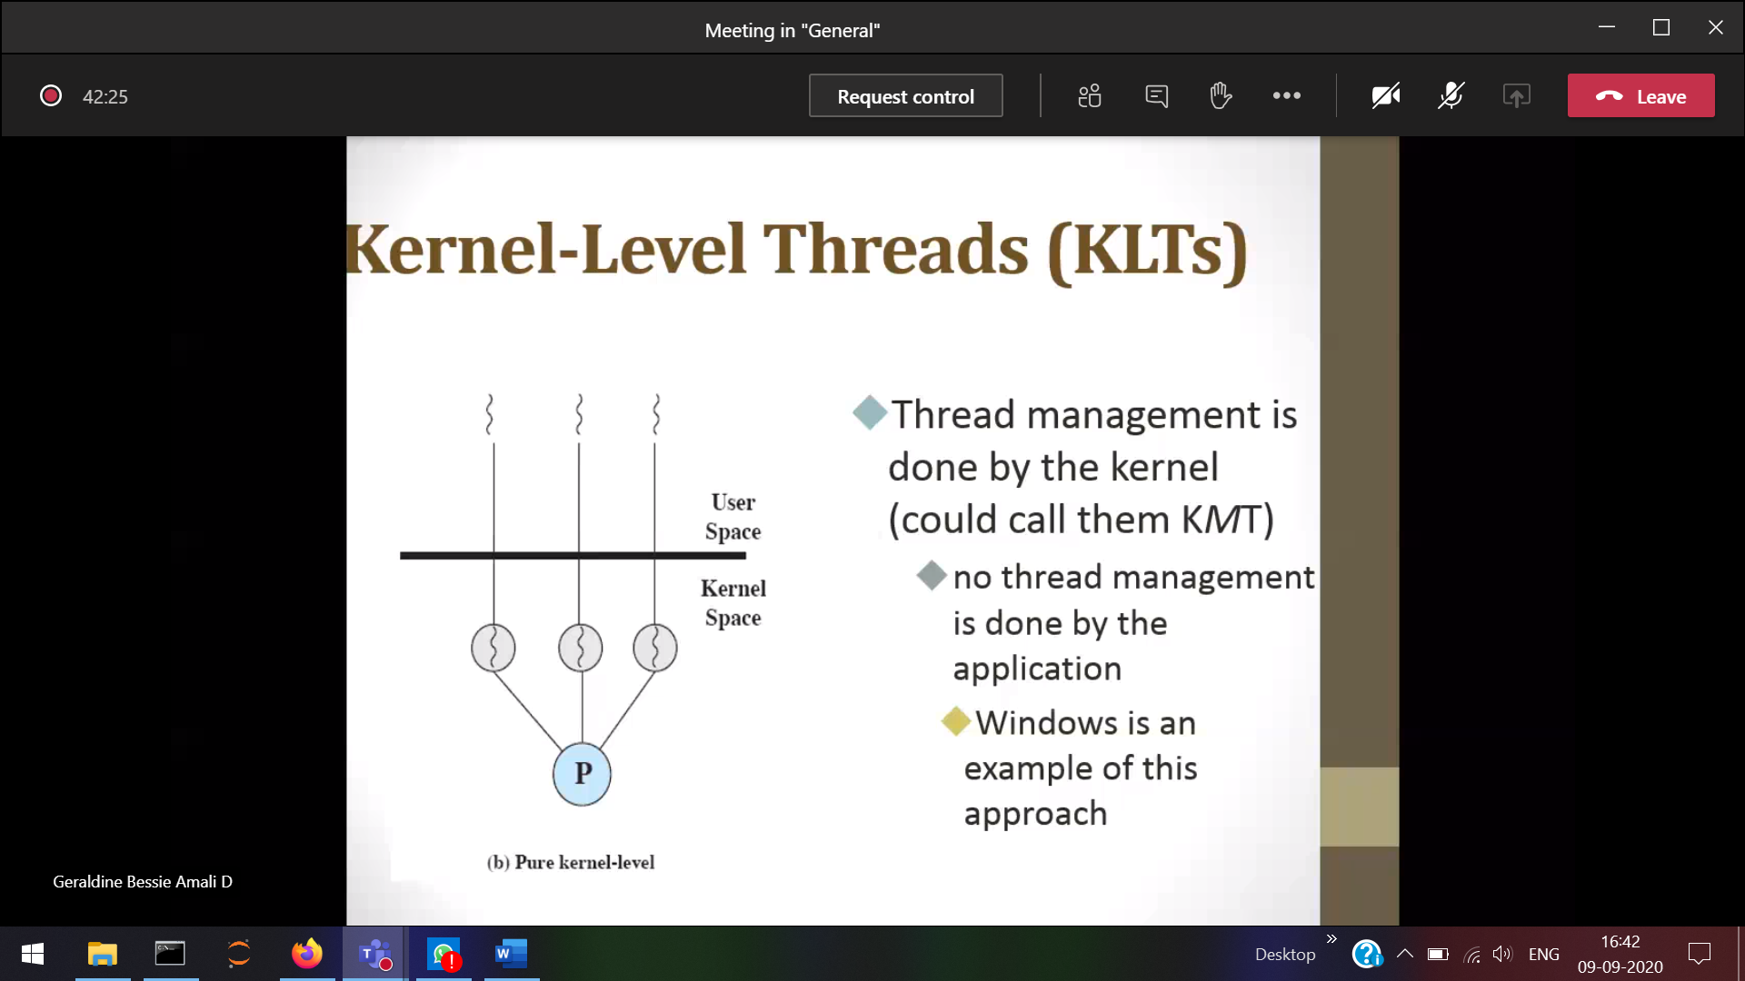

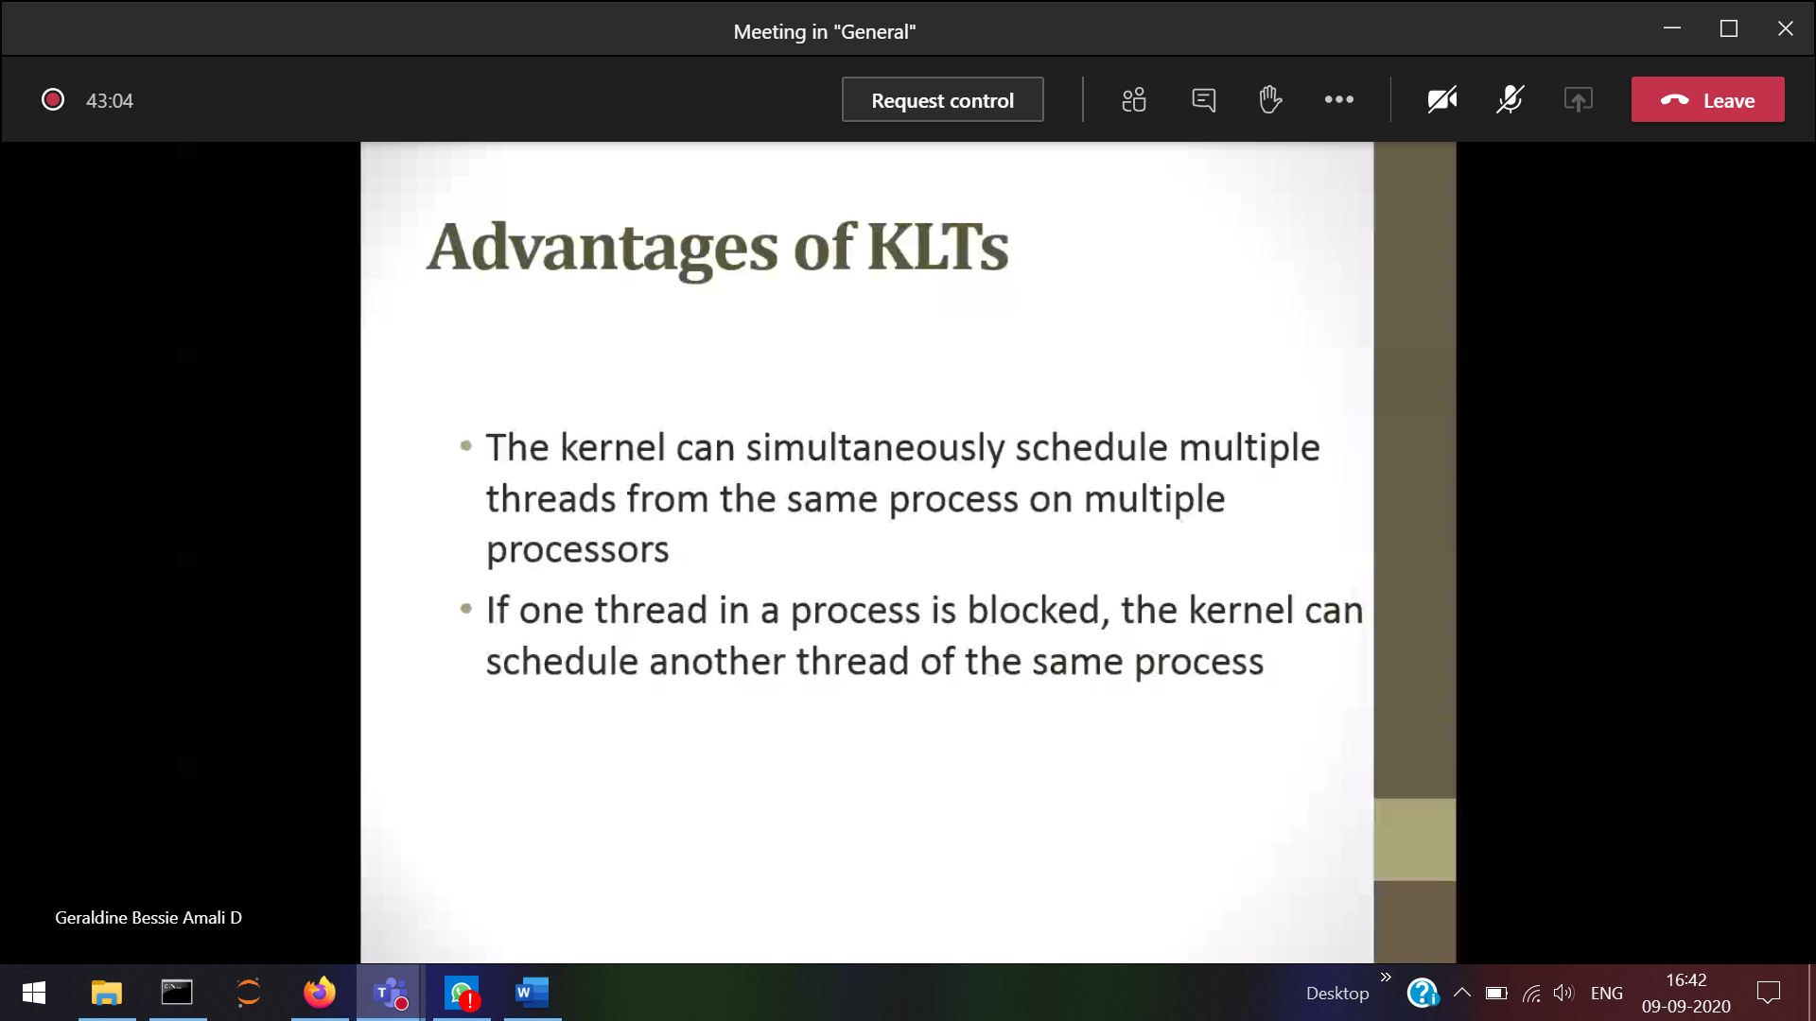

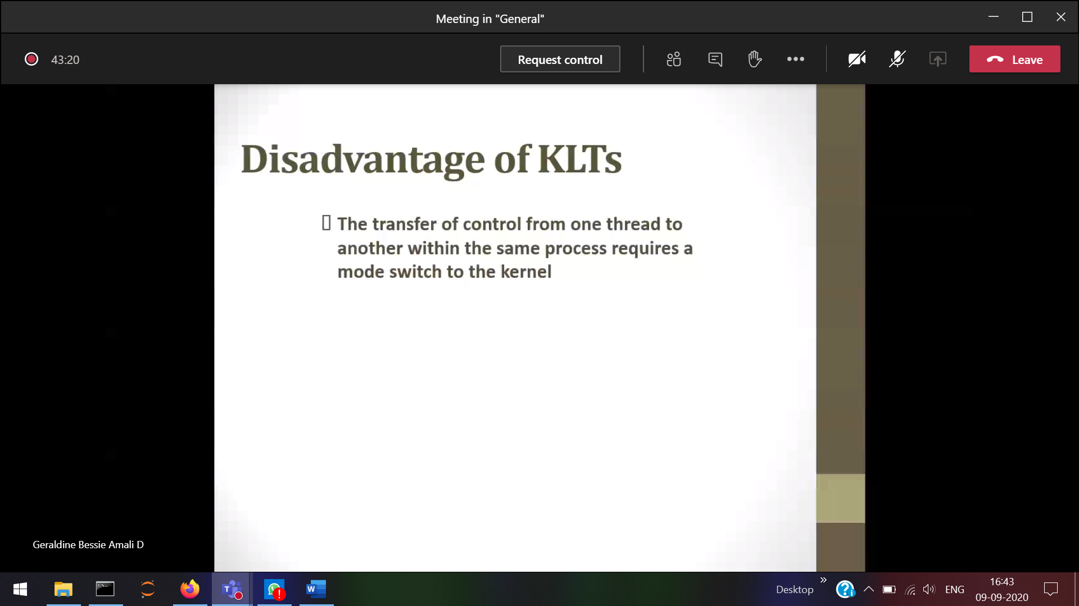

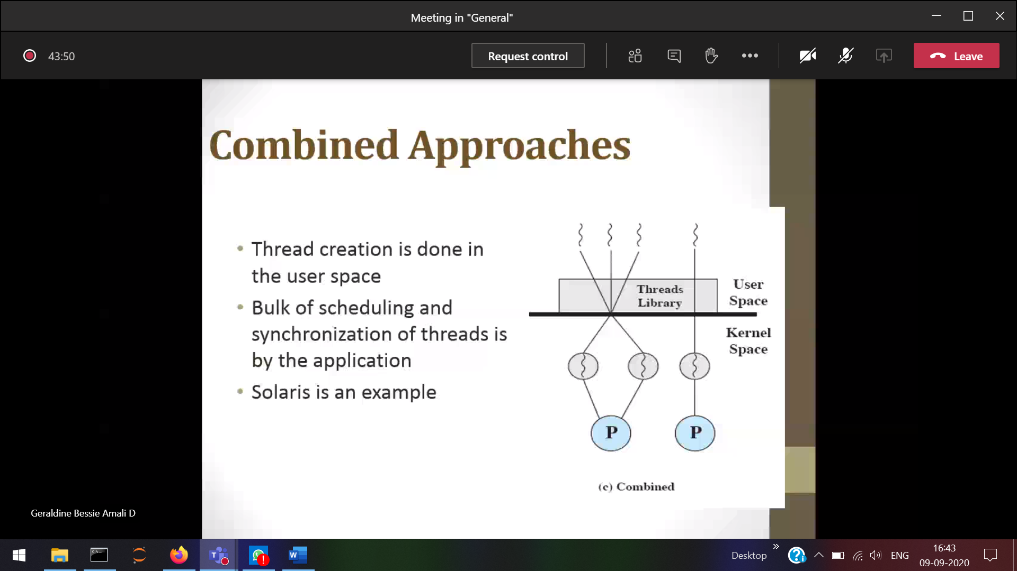

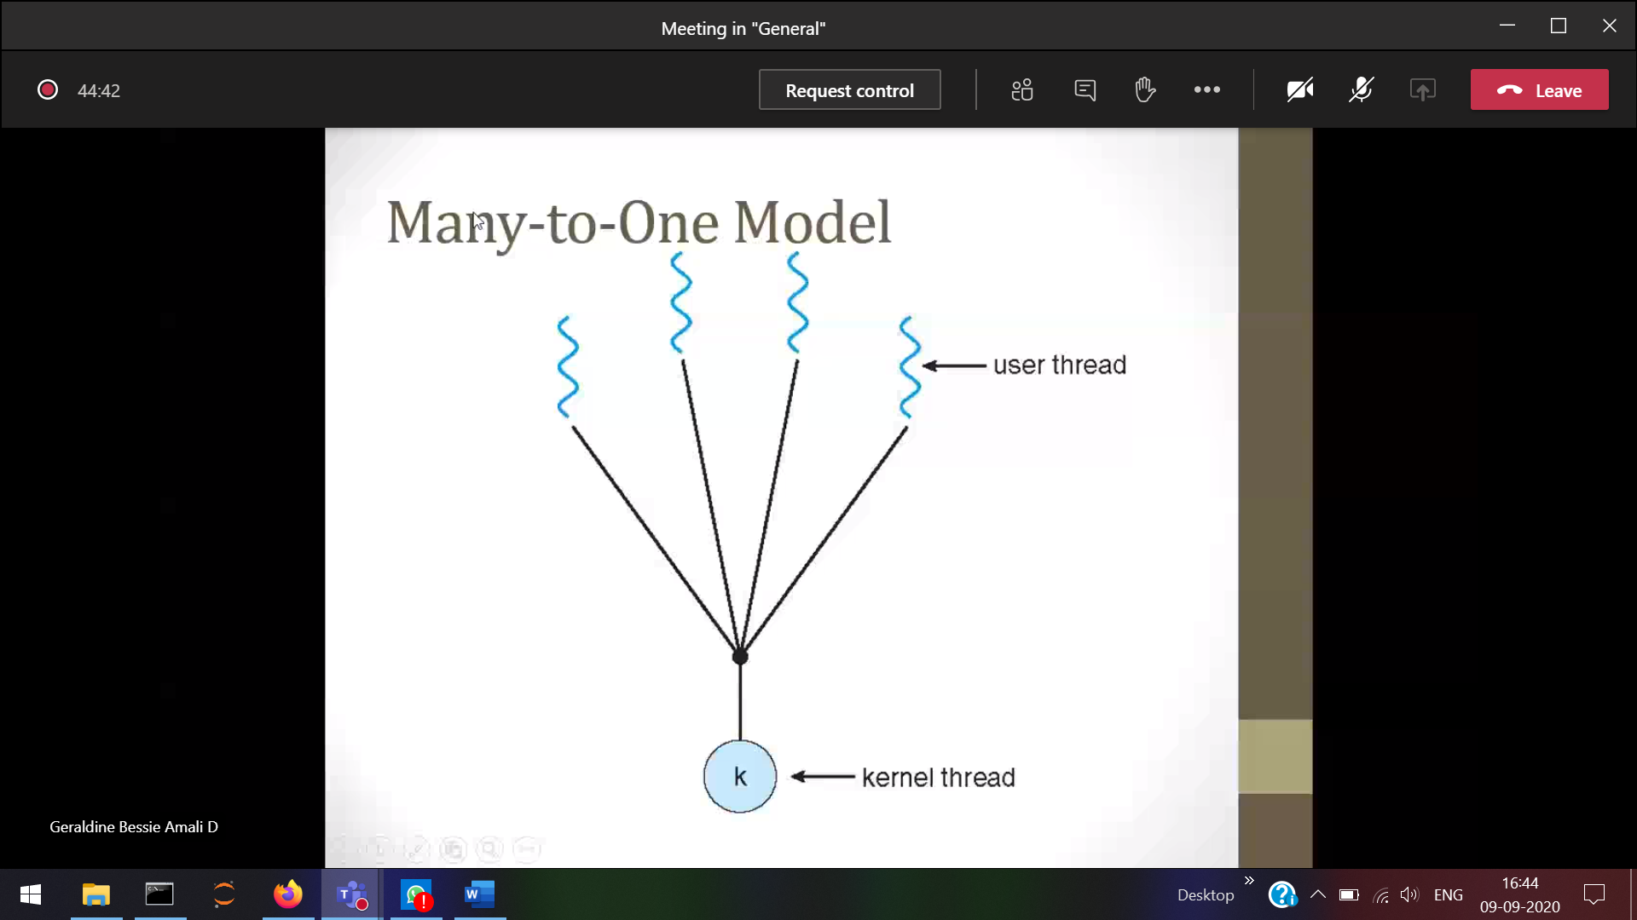

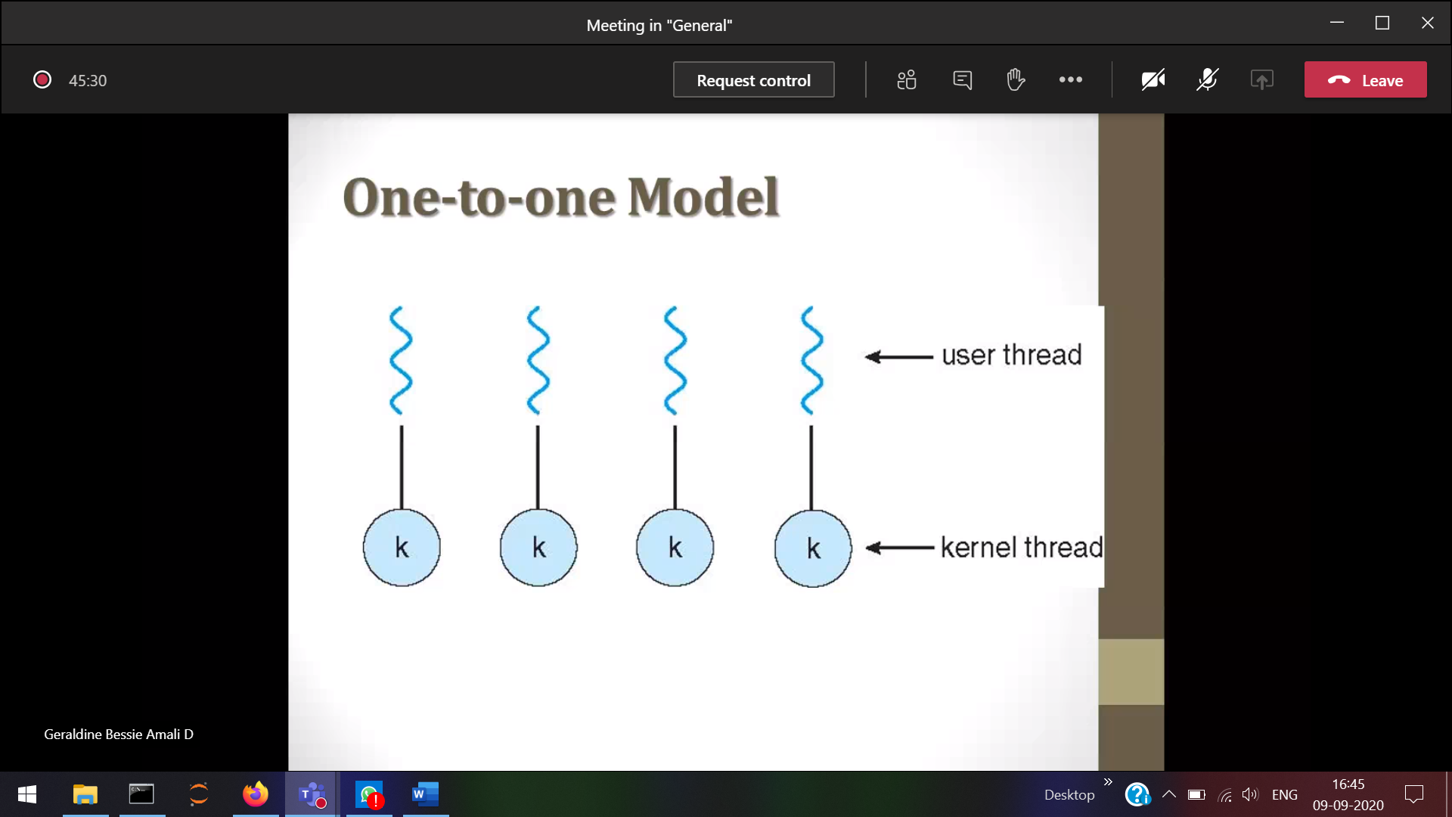

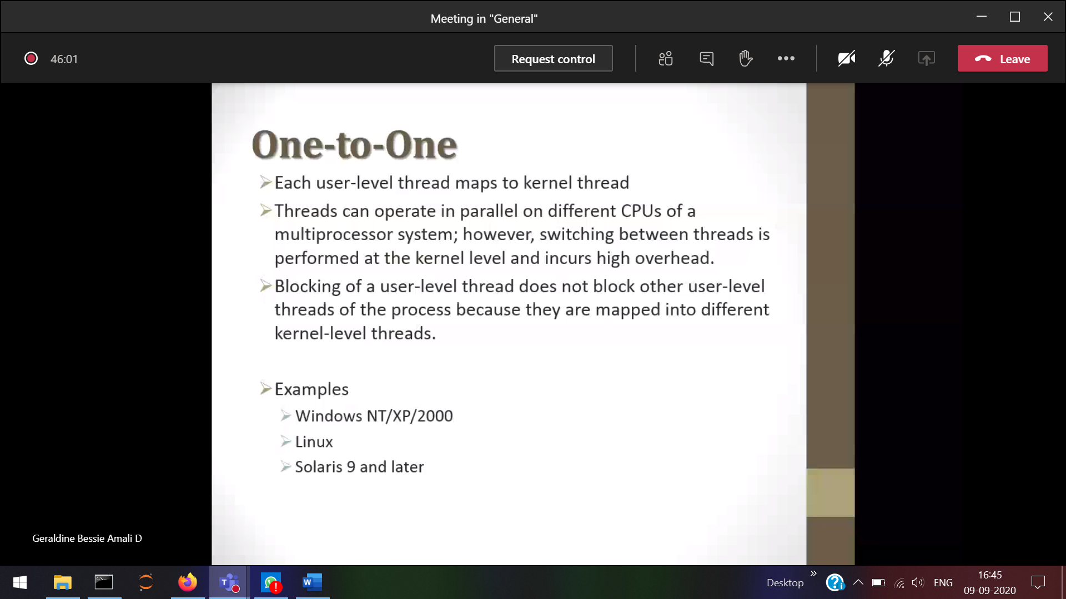

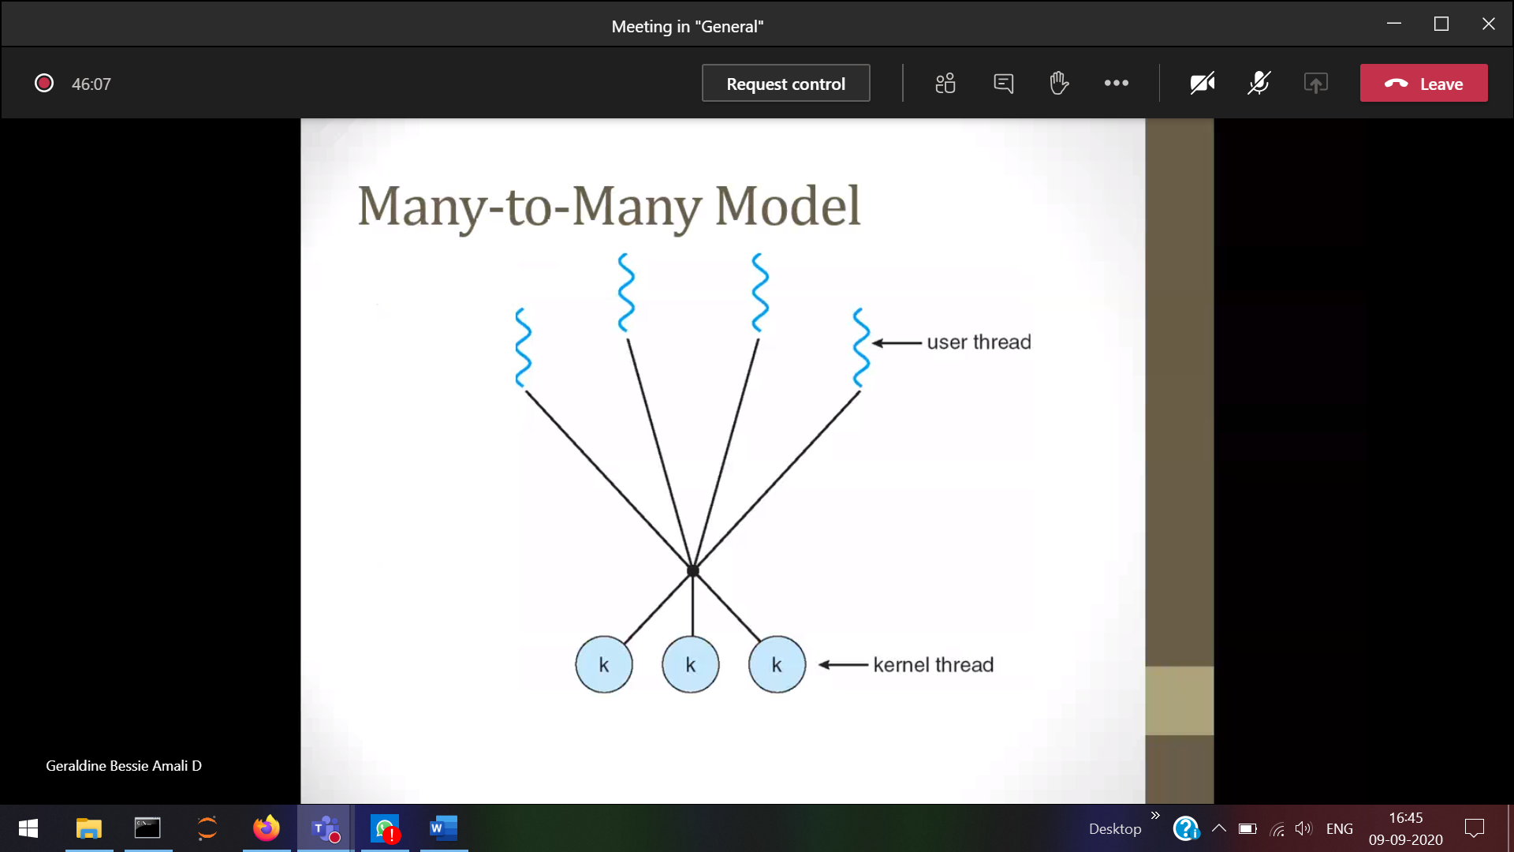

1 blocking in the user 🡪 does not affect another threads